- Constructing a scatter plot

Select the ‘Self Space’ and ‘Sales’ columns with data

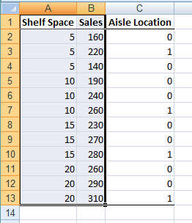

From the Menu (ribbon), select ‘insert’ tab and select ‘scatter with only markers’ from scatter drop down

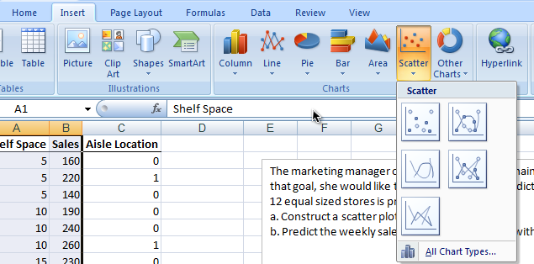
A scatter plot will be presented in the same spread sheet
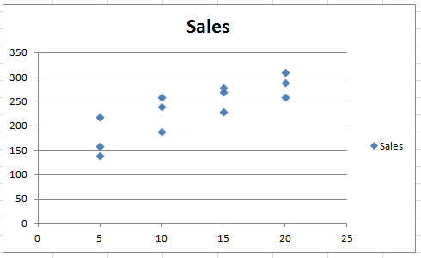

X-axis has ‘Self space’ (in sq. feet) and Y-axis has ‘Sales’ information. Above plot show some linear relationship between ‘Self space’ and ‘Sales’

- Next, we will fit a linear regression model and predict ‘Sales’ for 8 square feet ‘Self Space’
From the Menu bar (Ribbon), select ‘Data’ >> ‘Data Analysis’

Next, from the popup box select “Regression” and hit “OK”
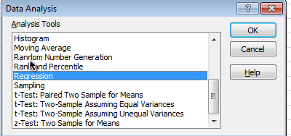

In the new “Regression” pop up box, Under the Input section, for “Input Y Range” select range of cells which has ‘Sales’ data (including the cell which contain ‘label’). Next, for “Input X Range” select range of cells which has ‘Self space’.
Check “Labels” option.
Check “Constant is Zero” (Constant is intercept in the linear regression model, for this particular example, this constant will be interpreted as average ‘Sales’ if ‘Self space’ is zero. We are assuming that there will be no ‘Sales’ if we don’t have any ‘Self space’ by checking this box)
Keep confidence level at default.
Check “New Worksheet Ply” under Output options.
Hit “OK”
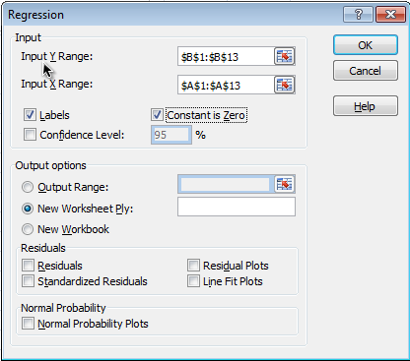
Output for the regression will be presented in new worksheet.
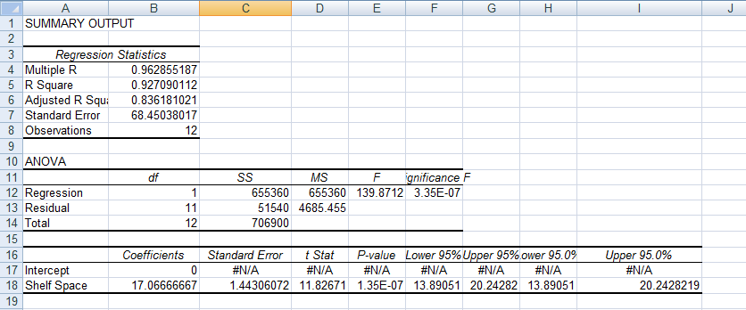

Above output shows, coefficient for ‘Self space’ is 17.06. It is interpreted as, average weekly sales will be 17.06 if we have 1 square feet of ‘Self space’.
So for 8 square feet of ‘Self space’ we will predict weekly sales of (17.06*8) 136.5.

