Solutions:

- Null hypothesis: There is no difference in mean waiting time between two branches
Mean_city = Mean_residential
Alternate hypothesis: There is difference in mean waiting time between two branches
Mean_city $≠$ Mean_residential

- Following are the steps to perform two sample t-test using excel analysis tool pak

From excel menu bar select Tools >> Data Analysis

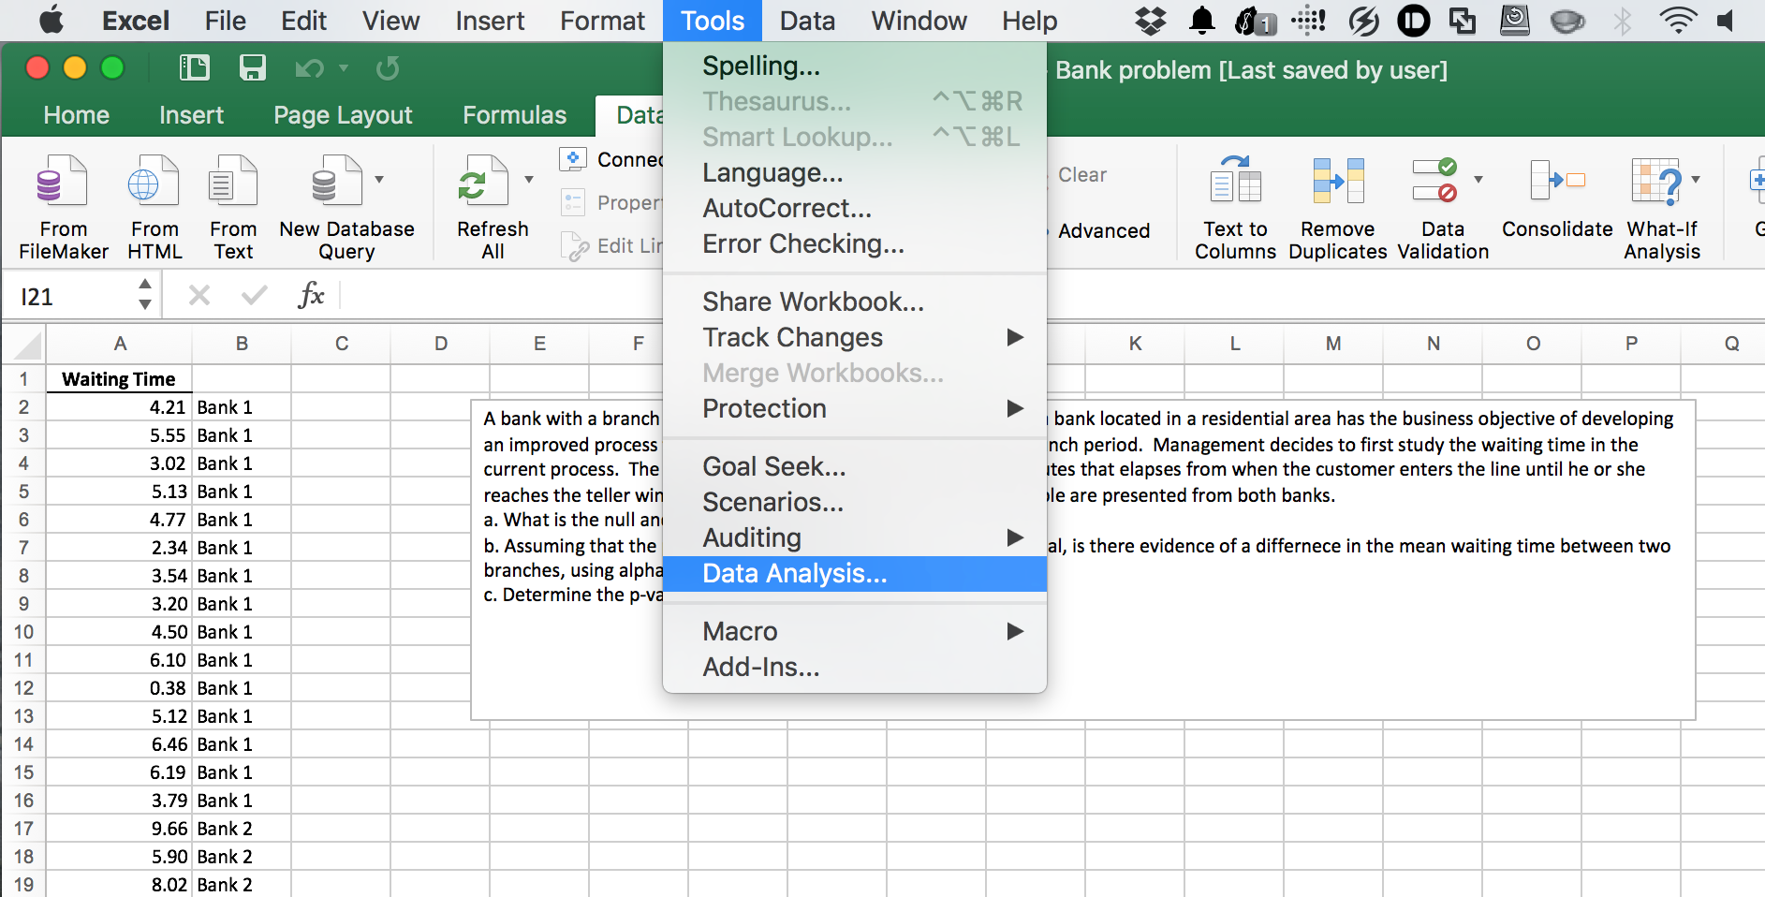

Next, from the popup box select “t-Test: Two-sample Assuming Equal Variances” and hit “OK”

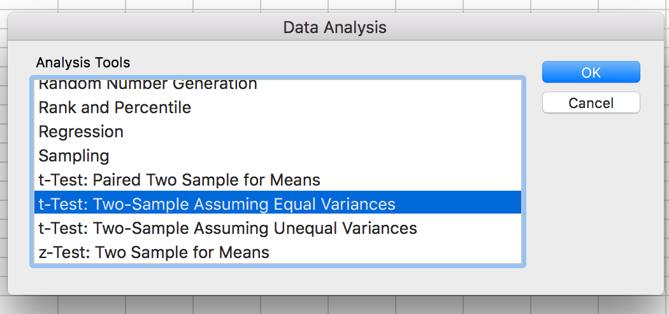
In the new “t-Test” pop up box, Under the Input section, for “Variable 1 Range” select range of cells which has waiting time for Bank 1. Next, for “Variable 2 Range” select range of cells which has waiting times for Bank 2.

As our null hypothesis is that the mean waiting time is same among Bank 1 and Bank2, the hypothesized mean difference is zero.

So, for “Hypothesized Mean Difference” put “0” value.

Keep “Alpha” value of “0.05” and check “New Worksheet Ply” under Output options.

Hit “OK”

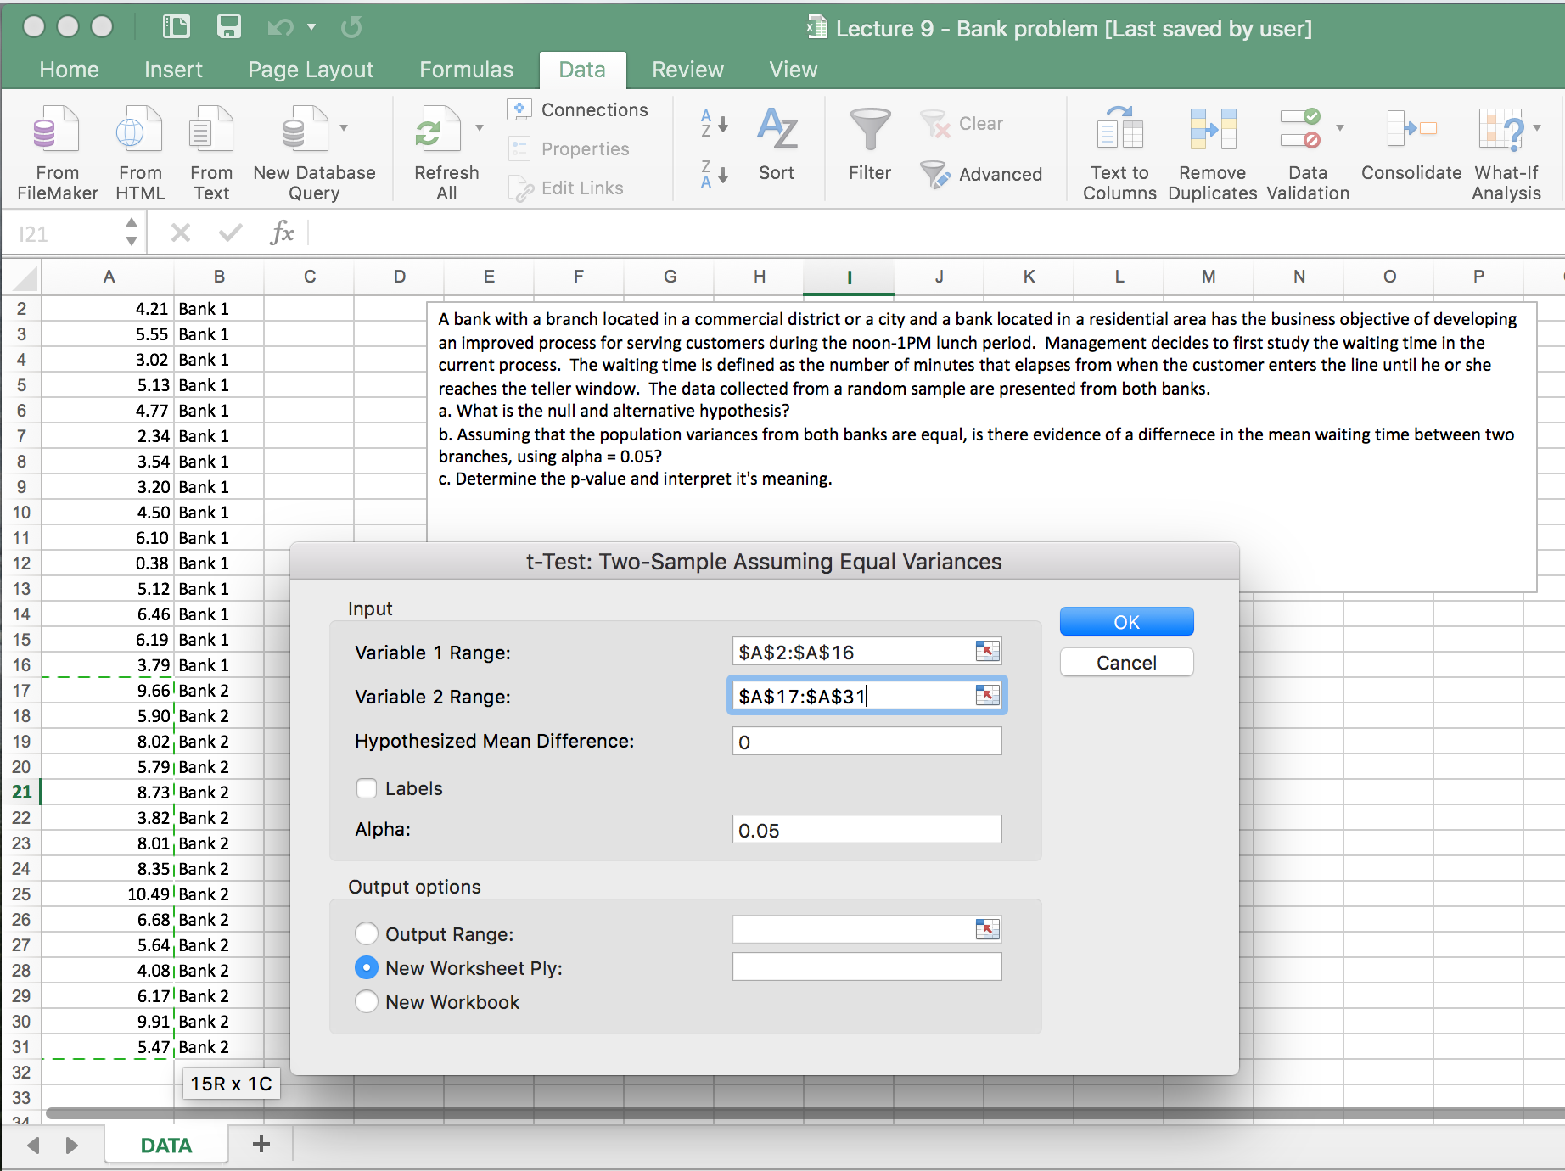

Output for the t-Test will be presented in new worksheet.

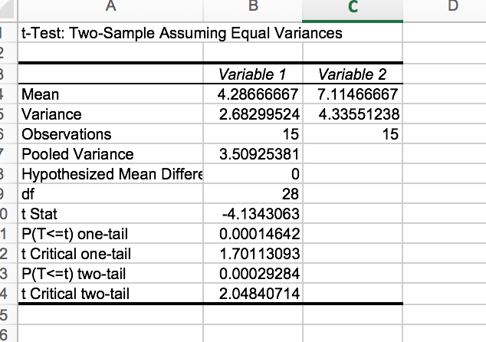

Above output shows that, mean wait time in Bank 1 was 4.28 minutes and 7.11 minutes in Bank 2. The t-test statistic was -4.13 and p-value for two-tailed test was 0.0003.

- Two-tailed p-value is 0.0003 which is less than 0.05 cut off value. So we reject null hypothesis and conclude that there was statistically significant difference in mean wait time in Bank 1 and Bank 2.

