Using the work breakdown structure below, what is the criticla path?
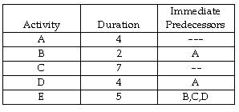
Calculate Estimated Time for An Activity
An activity on a PERT network has these time estimates: optimistic = 1, most likely = 4, and pessimistic = 9. What is its expected activity time?
T = (a +4m+b)/6
T = time
a = optimistic time
m = most likely time
b = pessimistic time
What is the forecast for May using a five-month moving average?
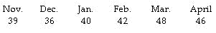
Exponential Smoothing - The smoothing constant determines the level at which previous observations influence the forecast.
Given an actual demand this period of 105, a forecast value for this period of 90, and an alpha of .3, what is the exponential smoothing forecast for next period?
Weighted Moving Average Forecast
John's House of Pancakes uses a weighted moving average method to forecast pancake sales. It assigns a weight of .6 to the previous month's demand, .3 to demand two months ago, and .1 to demand three months ago. If sales amounted to 1200 pancakes in May, 2350 pancakes in June, and 3500 pancakes in July, what should be the forecast for August?

