PROCESS STRATEGY: UNDERSTANDING PROCESS TYPES AND APPLICATIONS
You’re walking on a beach when you find an ancient lamp. You pick up the lamp, rub it, and watch as a genie appears in a puff of smoke. He tells you that he will grant you three wishes, and as it happens, there’s something you’ve always wanted.
“Help me bring my product to market on time and under budget,” you tell him.
“Whoa, whoa,” says the genie. “I do magical wishes, not miracles.”
The joke is that producing a product or service, bringing that product or service to the market, and getting that product or service into the hands of your customers (while building your customer base) is not a magical “black box” process. You can’t simply wish for it to happen. It also isn’t enough merely to find a way to produce what you sell — you must find the best way to produce what you sell, maximizing profits and minimizing costs while also considering the logistics of that production, distribution, customer service, and countless other factors.
PROCESS DESIGN
The complex world of Operations Management (OM) is the means through which a business entity defines how it will produce what it sells. Process design, one of the ten strategic decision areas in OM, comprises selecting the right process strategy and then implementing the correct processes required to conduct your operation and “deliver the goods” to the market.
Stated another way, you first must determine the strategy or “game plan” for how you will produce what you sell. You then must determine the exact steps needed to accomplish your strategy. Those steps are your processes, and they define how the business entity will do what it does.
PROCESS STRATEGY
A good process strategy — the right one for your business — enables the company to produce products that meet customer requirements within cost and managerial constraints. Choices made when it comes to your process strategy, and the design of your processes, will significantly affect your company’s efficiency, flexibility of production, and the cost and quality of the goods and services produced. If you choose your process strategy or design your processes poorly, the long-term health and success of your business will be harmed.
There are four basic process strategies. These are...
- Process focus
- Repetitive focus
- Product focus
- Mass customization

PROJECT, JOB SHOP, BATCH PROCESS, AND LINE PROCESS
The four basic process strategies are supported by processes. Processes are the specific activities undertaken to implement the process strategy. Types of processes include project, job shop, batch process, and line process.
PROJECT PROCESS
A project is a temporary endeavor undertaken to create a unique product, service, or result, according to the Project Management Institute. A project has a definite beginning and a definite end, although its duration varies.
Examples of projects include launching the Space Shuttle, an Enterprise Resource Planning (ERP) IT project, planning the company picnic, designing a new product, or improving a process with a Lean Six Sigma project.
Key management tasks involved in a project are planning, requirements determination, estimating, scheduling and sequencing of tasks to meet scope, as well as schedule and cost objectives.
JOB SHOP PROCESS
A job shop process has the flexibility needed to produce a wide variety of products, each product possibly requiring different sequences of processing steps. A job shop typically has a highly skilled workforce and makes use of general-purpose equipment. Products are made to order and are not produced ahead of time. A job shop supports projects as well as a process focus strategy.
In a job shop, each order is handled as a discrete “job.” Each customer order (or job) is fairly unique. Customization is high and volume for any one product is typically low.
Examples of job shop processes include processing an IT ticket to update custom websites, a tailor shop making custom suits, and making customized kitchen cabinets.
Key management tasks in job shops include estimating cost and delivery times, the need for fast response to orders, estimating production capacity, scheduling production, and breaking bottlenecks (solving problems that hold up production).
BATCH PROCESS
In a batch process, orders are handled in batches or lots. Similar products or parts are produced at the same time, repeatedly, as batches. A batch process has average or moderate volumes, but the products produced are still different enough that a separate process is needed for each product. The process flow is flexible, but some dominant or repetitive paths may emerge (in contrast to job shops). Some parts of the process even proceed as an assembly line would (they have a “line flow”).
Examples of batch processes include batch updates of large databases, baking a batch of cookies, fermentation of beer in vats, and making batches of standard components that feed an assembly line.
Key management tasks in a batch process are systematizing diverse elements, developing standards and methods, managing large, complex batch operations, and breaking bottlenecks (solving problems that hold up production).
LINE PROCESS (ASSEMBLY LINE)
In a line process (also called an assembly line), resources are organized around specific products, supporting a product focus strategy. Volumes are high and products are standardized. There is little divergence in the process or line flows, and little inventory is held between the processing steps. Discrete parts and products can be moved easily from one processing station, usually on a conveyor belt, to the next in order to repetitively build a product. Production and material handling equipment is specialized, organized around product flow. Some automated lines require substantial capital investment, which makes them hard to change.
Examples of a line process include exactly what you might expect: the assembly of everything from appliances, automobiles, and computers, to toys and even hamburgers (the typical fast food restaurant uses an assembly line process).
Key management tasks in an assembly line include developing standards and methods, balancing process stages, managing large, specialized and complex operations, and ensuring line equipment uptime (preventing the assembly line from stopping because a piece of equipment has failed).
CONTINUOUS PROCESS
A continuous process represents the extreme end of high-volume standardized production. Its line flows are rigid and its process divergence is negligible, meaning everything is standardized and there is little, if any, customization of the output. A continuous process typically involves one primary material (such as a liquid, gas, or powder) that moves without stopping in the process. Unlike a line flow, materials move through the process without stopping until the whole batch is finished. The time span can be several shifts or even several months.
Continuous processes support a product focus strategy.
Examples of a continuous process include oil refining, paper making, chemical processing, and processes to produce everything from steel to soft drinks and food (such as flour, pasta, chips, and processed foods).
Continuous processes are highly capital intensive. Key management tasks include meeting material requirements, running equipment at peak efficiency, timing expansion and technological change, and raising the required capital.
USING PROCESSES TO IMPLEMENT PROCESS STRATEGIES
There are many ways to implement each of these basic strategies. Let’s talk briefly about what each of them entails:
“PROCESS FOCUS” STRATEGY
In a process-focused strategy, the business’ facilities are organized around specific activities or processes, using general-purpose equipment and employing highly skilled personnel. Such a strategy results in a high degree of product flexibility. Costs are generally high, while equipment utilization is low. The “flow” of a product may vary considerably, so planning and scheduling becomes critical to produce a low volume of low-variety products. Processes typically employed to support a process focus strategy include projects, job shops, and batch processes.
A great example of a process-focus strategy in action is a car dealership garage. Other examples include custom workshops established for specific projects or small orders, such as Formula 1 racecars or tailored custom suits. Yet another example would be a hospital emergency room, or a financial institution handling client requests.
“REPETITIVE FOCUS” STRATEGY
In a repetitive-focused strategy, the business’ facilities are organized as assembly lines, which are often modular and include parts and assemblies made previously. Modules may be combined for many output options. A repetitive focus strategy offers less flexibility than a process-focused strategy, but it is more efficient. Processes typically employed to support a repetitive focus strategy include batch processes, line flows, and assembly lines.
Examples of manufacturing that uses a repetitive focus strategy include automobile and motorcycle manufacturers, home appliance manufacturers, and even loan application processing.
“PRODUCT FOCUS” STRATEGY
In a product-focused strategy, facilities are organized by product to produce a high volume of low-variety products. This type of strategy is geared toward long, continuous production runs, which makes it possible for the processes used to be very efficient. Fixed costs are usually high, but variable costs are low, and this strategy usually requires less skilled labor. Processes typically employed to support a product focus strategy include line flows and continuous processes.
Examples of the product focus strategy in action include sugar refining, chemical processing, potato chip production, soda bottling, and even credit card processing.
“MASS CUSTOMIZATION” STRATEGY
A mass customization strategy combines the flexibility of a process focus with the efficiency of a product focus. This is a high-production volume, high-product variety environment in which the rapid and low-cost production of goods and services is undertaken to satisfy increasingly unique customer desires.
A great example of this strategy applied is the Dell Computer company. Dell produces a high volume of computers that are customized (to a degree) and then built to order to meet specific customer requirements. Its strategy and its processes support this goal.
This brings us, in fact, to the concept of product volume versus product customization (and process characteristics). Every company must contend with these factors when choosing a strategy and then designing its processes to implement that strategy. A convenient way to visualize this intersection of production and process requirements is the product-process matrix.

PRODUCT-PROCESS MATRIX
The product-process matrix brings together product volume, product customization, and process characteristics in a single chart. It synchronizes the product (or service) to be produced with the transformation process itself. The product-process matrix was first introduced by Robert H. Hayes and Steven C. Wheelwright in two seminal articles in the Harvard Business Review in 1979.
The product-process matrix has two dimensions:
- The process structure/process life cycle describes the process choice on the type of process (project, job shop, batch, assembly line, and continuous processing) and process structure (jumbled flow, disconnected line flow, connected line flow, and continuous flow).
- The product structure/product life cycle describes the four stages of the product life cycle (low volume to high volume) and product structure (low to high standardization).

The product-process matrix, expanded, looks like this:
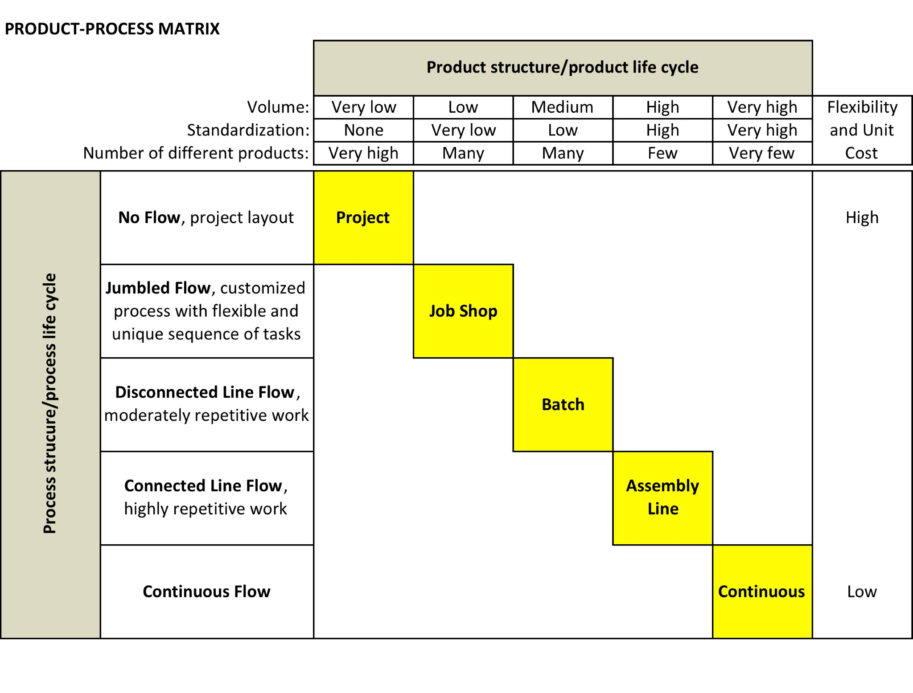
By evaluating its production requirements against both its process options and its process needs, a business entity can use the matrix to select the process strategy that best meets its needs.

THE IMPLICATIONS FOR BUSINESS LEADERS
The choice of process structure (process strategy and type of process) should be a conscious management decision. The process strategy and process type selected must support the product structure (product variety and volume) in order achieve the competitive priorities of the company. In other words, if a company is to position itself for competitive advantage, its product-process strategy and specific processes must support this goal (and do so in a way that is cost effective and efficient).
For example, a job shop cannot efficiently produce at high volumes and its unit costs will not be low enough to compete with an assembly line or a continuous process. However, a job shop has the flexibility in equipment and the highly skilled workforce needed to produce, competitively, custom orders that an assembly line or continuous process cannot.
The key management tasks are different for each type of process environment. This underscores the need not only to choose a process strategy and its supporting processes correctly to support the business entity’s goals, but also the need for ongoing examination and reevaluation of how well these decisions are enabling the business entity — and its leaders — to win.

