Numerical Data Representation
By Dr. Justin Bateh, Florida State College at Jacksonville &
Dr. Bert Wachsmuth, Seton Hall University

4.1 What is Numerical Data Representation?
As we have seen in chapter 1, statistics is the study of making sense of data and consists of four components: collecting, summarizing, analyzing, and presenting data. In the second and third chapter we focused on summarizing data graphically; in this chapter we will concern ourselves with summarizing data numerically.
While charts are certainly very nice and often convincing, they do have at least one major draw-back: they are not very "portable". In other words, if you conduct an experiment measuring cholesterol levels of male and female patients it is certainly great to create appropriate histograms to illustrate the outcome of your experiment. However, if you are asked to summarize your results, for example for a radio show or just during a conversation, these charts will not help much.
Instead you need a simple, short, and easy-to-memorize summary of your data that - despite being short and simple - is meaningful to others with whom you might share your results.
For example, in our study of levels of cholesterol we could condense the results by stating that the "average" level of cholesterol for men is X, while the average for women is Y, and most people would understand. Of course, when we condense data in this way, some level of detail is lost, but we gain the ease of summarizing the data quickly.
This chapter will discuss some "statistics" that can be used to summarize data numerically while still trying to capture much of the detailed structure hidden in the data. Among the descriptive statistics we will study are the mean, mode, and median, the range, variance, and standard deviation, and more detailed descriptors such as percentiles and skewness. Towards the end of the chapter we will learn about the "box plot" that combines many of the numerical descriptors in one picture.

4.2 Measures of Central Tendency: Mean, Median, and Mode
While charts are frequently very useful to visually represent data, they are inconvenient for the simple reason that they are difficult to display and cannot be remembered "by heart". It is frequently useful to reduce data to a couple of numbers that are easy to remember, easy to communicate, yet capture the essence of the data they represent. The mean, median, and mode are our first examples of such computed representations of data, and we will discuss how to compute each one and how to use Excel to simplify the calculation.

The Mean
The mean represents the average of all observations. It describes the "quintessential" number of your data by averaging all numbers collected. The formula for computing the mean is easy:
mean = (sum of all measurements) / (number of measurements)
In statistics, two separate letters are used for the mean:
- the Greek letter (mu) is used to denote the mean of the entire population, orpopulation mean
- the symbol (read as "x bar") is used to denote the mean of a sample, or sample mean
Another way to show how the mean is computed is:
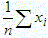
where n stands for the number of measurements, x stands for the individual measurements, and the Greek symbol sigma stands for "sum of". That formula is valid for computing either the population mean or the sample mean .
Of course, the idea - ultimately - is to use the sample mean as an estimate for the population mean (which is usually not known). For now, we will just show examples of computing a mean, and later we will discuss in detail how exactly the sample mean can be used to estimate the population mean.
Example: A sample of 7 scores from people taking an achievement test were taken. The numbers are:
95, 86, 78, 90, 62, 73, 89
Then the mean of that sample is:
= (95 + 86 + 78 + 90 + 62 + 73 + 89) / 7 = 573 / 7 = 81.9

Excel actually provides a simple function for computing averages, namely the
=average(RANGE)
function. Using Excel, we can simply compute the above mean by entering the seven data observations into a new spreadsheet, then find a convenient spot to display the average number, and finally entering the appropriate=average(RANGE) function, where RANGE should be replaced by the appropriate range of cells. Try it out now - the answer should of course be 81.9
Note: In Excel the =average(RANGE) function ignores cells containing no numeric data, i.e. cells that contain no data or text, do not contribute anything to the computation of the mean. Cells that contain a zero do, however, do contribute to the average.
The mean applies to numerical variables, and in some situations to ordinal variables. It does not apply to nominal variables.

The Median (or Middle Number)
The median is that number from a population or sample chosen so that half of all numbers are larger and half of the numbers are smaller then that number. The computation is actually different for an even or odd number of observations.
IMPORTANT: Before you try to determine the median you must first sort your data in ascending order.
Example: Compute the median of the numbers 1, 2, 3, 4, and 5.
The numbers are already sorted, so that it is easy to see that the median is 3 (two numbers are less than 3 and two are bigger).
Example: Compute the median of the numbers 1, 2, 3, 4, 5, and 6.
The numbers are again sorted, but neither 3 nor 4 (nor any other of the numbers) can be the median. In fact, the median should be somewhere between 3 and 4. In that case (when there are an even number of numbers) the median is computed by taking the "middle between the two middle numbers". In our case the median, therefore, would be 3.5 since that is the middle between 3 and 4, computed as (3 + 4) / 2.
Note that indeed three numbers are less than 3.5, and three are bigger, as the definition of the median requires.
For larger data sets, the median can be selected as follows:
- Sort all observations in ascending order
- If n is odd, pick the number in the (n+1)/2 position of your data
- If n is even, pick the numbers at positions n/2 and n/2 + 1 and find the middle of those two numbers

Note that this does not mean that the median is (n+1)/2 (if n is odd) but rather that the median is that number which can be found at position (n+1)/n.
The median is usually easy to compute when the data is sorted and there are not too many numbers. For unsorted numbers, or for lots of numbers, the median becomes quite tedious, mainly because you have to sort the data first. But of course Excel has a built-in function
=median(RANGE)
that will automatically compute the median of the numbers in a given range of cells.
Note: In Excel the =median(RANGE) function ignores cells containing no numeric data, i.e. cells that contain no data or text data, do not contribute anything to the computation of the median. Also, for an even number of numbers the median is automatically computed to be the middle between the two middle numbers.
The median applies to numerical variables, and in some situations to ordinal variables. It does not apply to nominal variables.
Discussion Topic: Discuss how to find the mean and the median of ordinal data, and why neither of these descriptive parameters makes any sense for nominal variables.

The Mode
The mode is that observation that occurs most often. It is usually not unique, and is therefore not that often used, but it has the advantage that it applies to numerical as well as categorical variables. As with the median, the mode is easy to find if the data is small and sorted:
Example: Scores from a test were: 1, 2, 2, 4, 7, 7, 7, 8, 9. What is the mode?
The mode is 7, because that number occurs more often than any other number.
Example: Scores from a test were: 1, 2, 2, 2, 3, 7, 7, 7, 8, 9. What is the mode?
This time the mode is 2 and 7, because both numbers occur three times, more than the other numbers. Sometimes variables that are distributed this way are called bimodal variables.
For data that consists of lots of numbers, and/or data that is not sorted, the mode, as the median, is cumbersome to compute by hand. Of course Excel provides an appropriate formula, in this case the
=mode(RANGE)
function. However, if the cell range consists several numbers with the same frequency (i.e. a bimodal variable as in the second example above) then the Excel =mode(RANGE) function returns only the first (smallest) number as the mode.
If all values occur exactly once, the Excel mode function returns N\A for "not applicable".

Mean, Median, and Mode: Pros and Cons
Since there are three measures of central tendency (mean, median, and mode) it is natural to ask which of them is most useful (and as usual the answer will be ... "it depends" -:)
The usefulness of the mode is in the fact that it applies to any variable. For example, if your experiment contains nominal variables then the mode is the only meaningful measure of central tendency (you could of course use frequency histograms to represent your data, as discussed in the previous chapter).
Mean and median usually apply in the same situations, so it is more difficult to determine which one is more useful. To understand the difference between median and mean, consider the following example:
Example: Suppose we want to know the average income of parents of students in this class. To simplify the calculations and to obtain the answer quickly, we randomly select 3 students to form a random sample. Let us consider two possible scenarios:
- Case 1: The three incomes may be, say, 25,000, 30,000, 35,000
- Case 2: The three incomes may be, say, 25,000, 30,000, 1,000,000
Compute mean and median in each case and discuss which one is more appropriate.
The actual computations are pretty simple.
- In case 1 the mean is 30,000 and the median is also 30,000.
- In case 2 the mean is 351,666, whereas the median is still 30,000
Clearly we were unlucky in case 2: one set of parents in this sample is very wealthy, but that is - probably - not representative for the students of the class. However, we selected a random sample, so scenario 1 is equally likely as scenario 2. Therefore it seems that the median is actually a better measure of central tendency than the mean, especially for small numbers of observations. In other words:
- the mean is influenced by extreme values, more so than the median
- the median is more stable and is the better measure of central tendency
However, for large sample sizes the mean and the median tend to be close to each other anyway, and the mean does have two other advantages:
- the mean is easier to compute than the median since it does not require sorted observations
- the mean has nice theoretical properties that make it more useful than the median
We will use both mean and median in the remainder of this course, while the mode will be less useful for us and will usually be ignored.
Exercise: Find the mean, mode, and median of the salary of Major League Baseball players. Why are they so different? Which one best represents the measure of central tendency? Did we compute the population mean (or median) or the sample mean (or median)?
major league baseball salaries

Incidentally, the measures of central tendency computed above represent population measures, since they took all major league baseball players into account. Had I only used a subset of players to compute mean, mode, and median, the values would be sample measures.

Mean and Median for Ordinal Variables
As I mentioned, the mean and median work best for numerical values, but you can compute them, in a matter of speaking, for ordinal variables as well.
Example: Suppose you want to find out how students like a particular statistics lecture, so you ask them to fill out a survey, rating the lecture "great", "average", or "poor". The 14 students in the class rank the lecture as
"great", "great", "average", "poor", "great", "great", "average", "great", "great", "great", "average", "poor", "great", "average"
Compute the mean, the mode, and the median.
Obviously the mode is "great", since that is the most frequent response. For the other measures of central tendency I have to introduce numeric codes for the responses. I could define, for example:
"great" = 1, "average" = 2, and "poor" = 3
Then my data is equivalent to
1, 1, 2, 3, 1, 1, 2, 1, 1, 1, 2, 3, 1, 2
Now it is easy to see that the average is 22 / 14 = 1.57 and the median is 1.
Of course the actual values for these central tendencies depend on the numeric code I am using for the original variables. I would need to justify or at least mention the codes I am using in a report so that the answers can be put in proper context. In a proper survey I would in fact list the code values together with the responses. One particular type of response that is frequently used in surveys is a Likert scale.

A Likert scale is a sequence of items (responses) that are usually displayed with a visual aid, such as a horizontal bar, representing a simple scale.
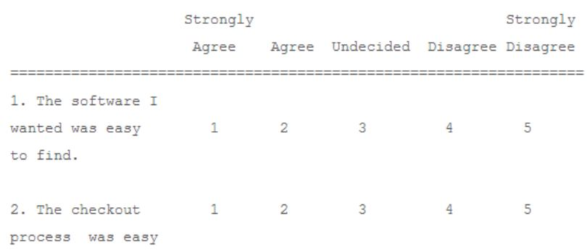

Mean, Mode, and Median for Frequency Distributions
We have seen how to compute mean, mode, and median for numeric data, and how to create frequency tables for categorical variables and histograms for numeric ones. As it turns out, it is possible to compute these measures of central tendency even if only the aggregate data in terms of a frequency table or histogram is available.
Example: Previously we looked at the heights of widgets produced in a certain factory:
3, 2, 5, 1, 4, 11, 3, 8, 23, 2, 6, 17, 5, 12, 35, 3, 8, 23, 6, 14, 41, 7, 16, 47, 8, 18, 53, 10, 22, 65, 9, 20, 59
We constructed a frequency table as follows from this data:
Category | Count
13.8 and less | 19
between 13.8 and 26.6 | 8
between 26.6 and 39.4 | 1
between 39.4 and 52.2 | 2
bigger than 52.2 | 3
Total | 33
Based solely on this table, estimate the mean and compare it with the true mean of the full data set.
If all we knew was this table, we argue as follows:
- 19 data points are between 1 and 13.8, that is 19 data points are averaging (1+13.8)/2 = 7.4
- 8 data points are between 13.8 and 26.6, that is 8 data points are averaging (26.6+13.8)/2 = 20.2
- 1 data point is between 26.6 and 39.4, or 1 data point averages (26.6+39.4)/2 = 33.0
- 2 data points average (39.4+52.2)/2 = 45.8
- 3 data points above 52.2, or between 52.2 and 65.0, so that 3 data points average (52.2+65)/2 = 58.6
Thus, we could estimate the total sum as:
19*7.4 + 8*20.2 + 1*33 + 2*45.8 + 3*58.6 = 602.6
and therefore the average would be approximately 602.6/33 = 18.26. The true average of the original data is 17.15. Thus, our estimate average is pretty close to the true average.
Of course if you had the original data, you would not need to do this estimation - you would of course use that data to compute the mean. But there are cases where you only have the aggregate data in table form, in which case you could use this technique to find at least an approximate value for the mean.
Example: A study of salaries of graduates from a University shows their income as follows:
Salary Range | Count
$7,200 - $18,860 | 130
$18,860 - $30,520 | 698
$30,520 - $42,180 | 254
$42,180 - $53,840 | 16
$53,840 - $65,500 | 2

Estimate the average incoming. Hint: you may use the following table (of course together with Excel) to get organized.
Salary Range | range midpoint | Count | product
$7,200 - $18,860 | 13030 | 130 | 1693900
$18,860 - $30,520 | 24690 | 698 | 17233620
$30,520 - $42,180 | 36350 | 254 | 9232900
$42,180 - $53,840 | 48010 | 16 | 768160
$53,840 - $65,500 | 59670 | 2 | 119340
Total |  | 1100 | 29047920
To estimate the average, we compute the blue values in the above table. Then we divide the sum of the products by the sum of the counts to get as average 29047920/1100 = $26,407.20
There is no way to determine the actual average from this table, since you don't really know how the numbers fit into the various intervals. We would need access to the original raw data to find the true mean. It turns out, though, that the true average, using the original data is $26,064.21 which is indeed close to our estimate. In a similar way you can compute the mean of an ordinal variable. Try some problems.
That settles finding the mean, but how do we find the median or the mode? Well, that is actually much easier than the mean:
- compute the percentages for the frequency table: the category with the largest percentage is the mode
- add a column named "cumulative percent" to the frequency table by computing the sum of all percentages of all categories below the current one: the median is the first category where the cumulative percent is above 50%

Example: Find the median and the mode of the following salary table
Salary Range | Count
$7,200 - $18,860 | 130
$18,860 - $30,520 | 698
$30,520 - $42,180 | 254
$42,180 - $53,840 | 16
$53,840 - $65,500 | 2
We add two columns to the table: one containing the frequency as percent and the second containing the cumulative percent:
Salary Range | Count | Percent | Cumulative %
$7,200 - $18,860 | 130 | 130/1100 = 11.8% | 11.8%
$18,860 - $30,520 | 698 | 698/1100 = 63.5% | 63.5+11.8 = 75.3%
$30,520 - $42,180 | 254 | 254/1100 = 23.1% | 75.3+23.1 = 98.4%
$42,180 - $53,840 | 16 | 16/1100 = 1.4% | 98.4+1.4=99.8%
$53,840 - $65,500 | 2 | 2/1100 = 0.2% | 99.8+0.2=100%
Total | 1100 | 100%
We can now see that the mode is the 2nd category $18,860-$30,520, since it occurs most often at 63.5% and the median is also the 2nd category, since it is the first one where the cumulative percent is above 50%.
Note that finding the median depends on the fact that the categories are ordered, of course, which means that the variable is ordinal (or numeric in case of a histogram).

4.3 How to select Random Samples
We have previously introduced the mean and the median. Now we want to see how to use Excel to compute these values for (reasonably) large data sets, as well as learn how to predict the population mean using a sample mean and/or median. First, we need a data set that we can analyze.
University of Florida Salary Levels
Click on the above Excel link to download an Excel spreadsheet that contains data about the salary levels of graduates from the University of Florida in the early 90's. The Excel spreadsheet should look similar to this (only the first few rows are displayed in the picture below):
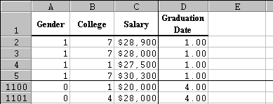
First, let's find the average as well as the median of the salary level for all graduates in the survey.
- Go to the end of column C
- Enter =average(, then use the mouse to select all cells in column C that contain numbers
- Type ) to close the parenthesis, then hit RETURN
- Move one cell below the average
- Enter the formula =median(, then use the mouse to select all cells in column C that contain numbers except, of course, the cell containing the current average that was previously computed.
- Type ) to close the parenthesis, then hit RETURN
- Add some labels in front of the numbers just computed

Here are the answers (and the formulas used to compute them):
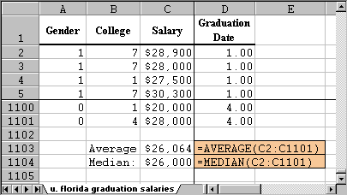
In other words, according to our data we would say that the average salary of all graduates from the University of Florida earned approximately $26,000.
Note that the mean and the median are very close together, which is usual for a "balanced" distribution (we'll define that a little later). From the information we have about the data set, we actually do not know if the data really contains all graduates or just a representative sample.
- If the data did include all graduates, $26,064 is the population mean, and there is no statistical error involved.
- If the data did not include all graduates, but a representative sample instead, then $26,064 would be the sample mean, and we would use that as an estimate for the (unknown) population mean. In this case, we really should also provide a margin of error for our estimate - we will do that in a later module.
While Excel can compute the mean and median very quickly for this data set, it would be tedious to do so "by hand". To simplify the computation and to illustrate the difference between population mean and sample mean, we will assume that the Excel data set is the entire information for all recent graduates of the University of Florida and do the following:
- Select 10 salaries at random from that data set. These numbers form a sample of size 10.
- Compute the mean and median of this sample (which is easy to do, even with a calculator)
- Compare this sample mean and median to the actual population mean

Selecting a Random Sample from a Population
The problem in the above example is how to select the 10 numbers "at random". To remove any bias (which we would introduce if we attempt to pick randomly "by hand", say), we will use Excel's random sample selection tool:
- Ιn Excel, click on "Data" and select "Data Analysis ..."
- Scroll down and select "Sampling", then click on "OK". You should see a dialog window similar to this:
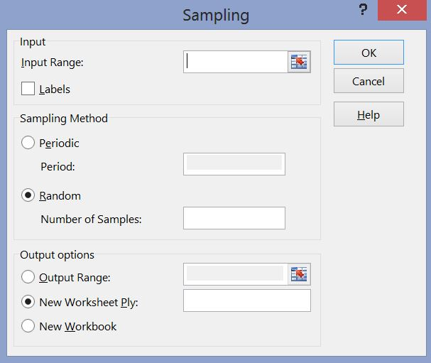
Use the "cell selector" icons to select all cells containing salaries, and enter the sample size of 10 in the "Number of Samples:" input field.
Note that in this dialog box the sample of size 10 will go into a new worksheet. Click OK and a sample of size 10 is selected at random. In our case, the sample data is as follows (note that since the sample is selected at random, your numbers will differ from the ones below):
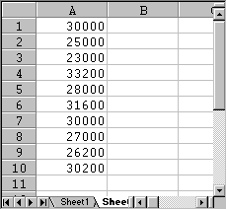
- Now let's use the standard =average(RANGE) and =median(RANGE) functions for this sample set to compute the sample mean and median, as in the following picture:
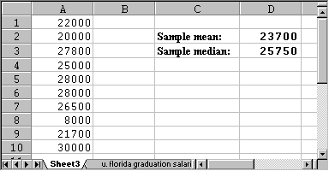
In other words, the sample mean we computed using 10 salaries is $23,700, and the sample median is $25,750 (again, your numbers will be different since your random sample should be different). Either number is a reasonable estimate for the actual population mean which was about $26,000.
To complete a valid statistical analysis, we should also provide a maximal error for our estimation, but we will cover that in a later module.
Discussion Topic: If you repeated the above exercise once for really small sample sizes, and again for larger sample sizes, which would give better estimates?
Note that computing the sample mean for only 10 numbers is very easy and the result is pretty close to the actual population mean of over 1,100 salaries. We have therefore achieved a compromise: we use less effort for our computation of the mean, but our answer will be somewhat less accurate. Alternatively, we could expend a lot of effort in the computation of the mean (using the entire population) and as a benefit our result will be totally accurate.

4.4 Measures of Variability: Range, Variance, and Standard Deviation
While mean and median tell you about the center of your observations, it says nothing about the 'spread' of the numbers.
Example: Suppose two machines produce nails which are on average 10 inches long. A sample of 11 nails is selected from each machine.
- Machine A: 6, 8, 8, 10, 10, 10, 10, 10, 12, 12, 14
- Machine B: 6, 6, 6, 8, 8, 10, 12, 12, 14, 14, 14
To verify, let's compute the mean:
- mean for machine A: 110 / 11 = 10
- mean for machine B: 110 / 11 = 10
In both cases, the mean is 10, indeed. However, the first machine seems to be the better one, since most nails are close to 10 inches. Therefore:
We must find additional numbers indicating the 'spread' of the data.

The Range
The easiest measure of the data spread is the range. It is simply the highest data value minus the lowest data value (we have seen the range before). In the above example, the range is the same for both data, namely 14 - 6 = 8. The range is, while useful, too crude a measure of variability.

The Variance
We want to find out how much the data points are spread around the mean. To do that, we could find the difference between each data point and the mean, and average these differences. However, we want to measure the differences to the mean regardless of the sign (positive or negative difference). Therefore, we could find the absolute value of the difference between each data point and average that. But for theoretical reasons an absolute value function is not easy to deal with, so that one chooses a square function instead (which also neutralizes signs). Finally, for yet other theoretical reasons we shall use not the sample size n to compute an average, but instead n-1.
Hence, we will use this formula to compute the data spread, or variance:
Variance = add up the squares of (Data points - mean), then divide that sum by (n - 1)
There are two symbols for the variance, just as for the mean:
- is the variance for a population
- is the variance for a sample
In other words, the variance is computed according to the formulas:
- 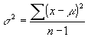(for the population variance)
- 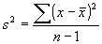(for the sample variance)

We had to use two formulas because one involves the population mean, the other the sample mean. Practically, however, the formula is the same. It is useful to compute the variance at least once "by hand" before we show how to use Excel to accomplish the same feat quickly and easily.

How to find the variance "by hand":
- Make a table of all x values
- Find the mean of the data
- Include a column with the difference to the mean
- Include a column with the square of difference to the mean
- Add the last column and divide the sum by (n - 1).
Here is the table that this procedure produces for the above sample of nails from machine A and B:
Machine A:
x
6 | 4 | 16
8 | 2 | 4
8 | 2 | 4
10 | 0 | 0
10 | 0 | 0
10 | 0 | 0
10 | 0 | 0
10 | 0 | 0
12 | -2 | 4
12 | -2 | 4
14 | 4 | 16
Therefore, the variance for machine A is: (16 + 4 + 4 + 0 + 0 + 0 + 0 + 0 + 4 + 4 + 16) / 10 = 48 / 10 = 4.8
Machine B:
x
6 | 4 | 16
6 | 4 | 16
6 | 4 | 16
8 | 2 | 4
8 | 2 | 4
10 | 0 | 0
12 | -2 | 4
12 | -2 | 4
14 | -4 | 16
14 | -4 | 16
14 | -4 | 16
Therefore, the variance for machine B is: (16 + 16 + 16 + 4 + 4 + 0 + 4 + 4 + 16 + 16 + 16) / 10 = 112 / 10 = 11.2
In other words, the variance, or spread around the mean, for machine A is 4.8 while machine B has a variance (spread) of 11.2. That means that machine A, as a rule, produces nails that stick pretty close to the average nail length. Machine B, on the other hand, produces nails with more variability that machine A. Therefore, Machine A would be much preferred over machine B.
Note: The unit of the variance is the square of the original unit; hence, it is not the best number (considering units). Therefore, one introduces an additional number, called the standard deviation:

The Standard Deviation
The standard deviation is the square root of the variance.
As with the mean, there are two letters for variance and standard deviation:
- $σ^{2 }$is the variance for a population and $σ= \sqrt{σ^{2}}$ is the population standard deviation
- $s^{2 }$is the variance for a sample and $s= \sqrt{s^{2}}$is the sample standard deviation
Example: Consider the sample data 6, 7, 5, 3, 4. Compute the standard deviation for that data.
To compute the standard deviation, we must first compute the mean, then the variance, and finally we can take the square root to obtain the standard deviation. In this case we do not need to create a table since there are so few numbers:
- Computing the mean:
- Computing the variance:
- Standard deviation:

Short-Cut for Variance
There is a nice short-cut to compute the variance that can be proved as an exercise:
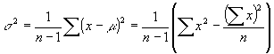
At first this second formula looks much more complicated, but it is actually easier since it does not involve computing the mean first. In other words, using the second formula we can compute the variance (and therefore the standard deviation) without first having to compute the mean.

In our above example of machine B we would compute the variance using this shortcut as follows:
x | x²
6 | 36
6 | 36
6 | 36
8 | 64
8 | 64
10 | 100
12 | 144
12 | 144
14 | 196
14 | 196
14 | 196
sum(x) = 110 | sum(x²) = 1212
Therefore the variance is:
1/ (11 - 1) * (1212 - 110²/11) = 0.1 * (1212 - 1100) = 11.2
which of course is the same number as before, but a little easier to arrive at. However, Excel - as usual - provides built-in function to compute the range, the variance, and the standard deviation.
If you need to compute the variance manually, you should always use this shortcut formula.

Using Excel to compute Range, Variance, and Standard Deviation
Excel provides simple formulas to compute the range, the variance, and the standard deviation:
- to compute the range: "=max(RANGE) - min(RANGE)"
- to compute the variance: "=var(RANGE)"
- to compute the standard deviation: "=stdev(RANGE)"
Example: Use the above formulas to compute the mean, the range, the variance, and the standard deviation of the salaries of graduates for the University of Florida. The data set (in Excel format) can be obtained by using the University of Florida Salary Levels data set we utilized beore.
All that is involved here is adding the appropriate formulas to the Excel worksheet. The results (including the formulas) are displayed below:
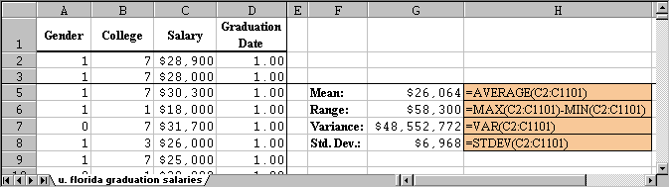
Note: The variance is displayed as dollars, even though that is not correct. The correct unit for the variance, of course, is "square dollars" which does not make much sense. The standard deviation, on the other hand, has indeed dollars as unit.

4.5 Quartiles and Percentiles
At this point we can describe the results of an experiment using 2 numbers (or parameters): the mean (or median) and the standard deviation (computed from the variance). That will tell us the "center" of the distribution of values (mean) and the "spread" around that center (standard deviation). For example, if we measure the height of US army soldiers we could say that the average height of US soldiers is 1.73 meters, with a standard deviation of 0.15 meters (the numbers are made-up). This gives you a reasonable idea about how a generic solder looks like (he/she is about 1.73 m tall) and how much variation from that generic look there is. To describe the distribution in more detail we need additional descriptive measures.

Upper and Lower Quartiles
- The Lower Quartile Q₁ is that number such that 25% of observations are less than it and 75% are larger, or to be more precise, at least 25% of the sorted values are less than or equal to Q₁ and at least 75% of the values are greater than or equal to Q₁.
- The Upper Quartile Q₃ is that number such that 75% of observations are less than it and 25% are larger, or to be more precise, at least 75% of the sorted values are less than or equal to Q₃, and at least 25% of the values are greater than or equal to Q₃.
Following this notation, the median should actually be called the "middle quartile" Q₂, since it is that number such that 50% are less than it and 50% are larger.
NOTE: To find the quartiles, you must first sort your data (similar to finding the mean).
Example: Compute the upper and lower quartiles of the numbers 1, 2, 3, 4, 5, 6, 7.
The numbers are already sorted, so that it is easy to see that the median is 4 (three numbers are less than 4 and three are bigger). In other words, 4 splits our numbers up into the set of smaller numbers {1, 2, 3} and the set of larger ones {5, 6, 7}. The quartiles, in turn, split up these sets in the middle, so that Q₁ = 2 and Q₃ = 6.
Note that the numbers 1, 2 are less than or equal to the lower quartile, while 2, 3, 4, 5, 6, 7 are larger than or equal to Q₁. Therefore, 2 out of 7 or 28% of values are less than or equal to Q₁ and 6 out of 7 = 86% are larger than Q₁.
Example: Compute the upper and lower quartiles of the numbers 1, 2, 3, 4, 5.
Now the median is 3, leaving two sets {1, 2} and {4, 5}. To split these numbers in the middle does not work, so it is not immediately clear what the quartiles are.
- If Q₁= 1, then one value out of 5 is less than or equal to Q₁, or 20%. That's not correct, so Q₁ must be bigger than 1.
- If Q₁ = 2, then two values out of 5 are less than or equal to Q₁, or 40%. Similarly, 4 values out of 5 , or 80%, are larger than or equal to Q₁ so that the lower quartile is 2.
Similarly, the upper quartile can be shown to be 4.
For larger data sets, the quartiles can be selected as follows:
For Lower Quartile:  - Sort all observations in ascending order  - Compute the position L₁ = 0.25 * N, where N is the total number of observations.  - If L₁ is a whole number, the lower quartile is midway between the L₁-th value and the next one.  - If L₁ is not a whole number, change it by rounding up to the nearest integer. The value at that position is the lower quartile. | For Upper Quartile:  - Sort all observations in ascending order  - Compute the position L₃ = 0.75 * N, where N is the total number of observations.  - If L₃ is a whole number, the lower quartile is midway between the L₃-th value and the next one.  - If L₃ is not a whole number, change it by rounding up to the nearest integer. The value at that position is the lower quartile.
Examples: Find the quartiles for the values 1, 2, 3, 4, 5, 6, 7 and also for the values 1, 2, 3, 4, 5 using this new method.
For the set 1, 2, 3, 4, 5, 6, 7 we have N = 7. Thus:
- L₁ = 0.25 * 7 = 1.75, which gets rounded up to 2. Thus, I take the number in the 2nd position to be the lower quartile
- L₃ = 0.75 * 7 = 5.25, which gets rounded up to 6. Thus, I take the 6th number (i.e. 6) to be the upper quartile.
For the set 1, 2, 3, 4, 5 we have N = 5. Thus:
- L₁ = 0.25 * 5 = 1.25, which gets rounded up to 2. Thus, I again take the number in the 2nd position to be the lower quartile
- L₃ = 0.75 * 5 = 3.75, which gets rounded up to 4. Thus, I take the 4th number (i.e. 4) to be the upper quartile.

Percentiles
Quartiles are useful and they help to describe the distribution of values as we will see later. However, we often want to know how one particular data value compares to the rest of the data. For example, when taking standardized test scores such as SAT scores, I want to know not only my own score, but also how my score ranks in relation to all scores. Percentiles are perfect for this situation.
The k-th Percentile is that number such that K % of all data values are less and (100 - K) % are larger than it. More precisely, at least K% of the sorted values are less than or equal to it and at least (100 - K)% of the values are greater than or equal to it.
Note: The lower quartile is the same as the 25th percentile, the median is the same as the 50th percentile, and the upper quartile is the same as the 75th percentile.

To find the k-th Percentile:
- Sort all observations in ascending order
- Compute the position L = (k/100) * N, where N is the total number of observations.
- If L is a whole number, the k-th percentile is the value midway between the L-th value and the next one.
- If L is not a whole number, change it by rounding up to the nearest integer. The value at that position is the k-th percentile.
Example: Consider the following cotinine levels of 40 smokers:
0 | 87 | 173 | 253 | 1 | 103 | 173 | 265 | 1 | 112
198 | 266 | 3 | 121 | 208 | 277 | 17 | 123 | 210 | 284
32 | 130 | 222 | 289 | 35 | 131 | 227 | 290 | 44 | 149
234 | 313 | 48 | 164 | 245 | 477 | 86 | 167 | 250 | 491
Find the quartiles and the 40th percentile.
First note that before we start our computations we must sort the data - computing percentiles for non-sorted data is the most common mistake (so please avoid it). Here is the same data again, this time sorted:
0 | 1 | 1 | 3 | 17 | 32 | 35 | 44 | 48 | 86
87 | 103 | 112 | 121 | 123 | 130 | 131 | 149 | 164 | 167
173 | 173 | 198 | 208 | 210 | 222 | 227 | 234 | 245 | 250
253 | 265 | 266 | 277 | 284 | 289 | 290 | 313 | 477 | 491
Now we can do our calculations, where N = 40 (number of values in our data set).
- Lower Quartile: 0.25 * 40 = 10, so we need to take the value midway between the 10th value, which is 86, and the 11th value, which is 87. Hence, the lower quartile is 86.5
- Upper Quartile: 0.75 * 40 = 30, so we need to take the value midway between the 30th value, which is 250, and the 31st value, which is 253. Hence, the upper quartile is (250 + 253) / 2 = 251.5
- 40th Percentile: 0.4 * 40 = 16, so the 40th percentile is (130 + 131) / 2 = 130.5
However, for percentiles another question is usually asked: given a particular value, find that percentile that corresponds to this value. In other words, determine how many values are less and how many values are larger than the particular value.
To find the percentile that corresponds to a particular data value x is:
- percentile value of x = (number of values less than x) / (total number of values) * 100
Example: Suppose you took part in the above study of cotinine levels, and your personal continine level was 245. What is the percentile value of 245, and how many people in the study had a higher cotinine level that you?
First note that in our sorted data the value 245 is in 29th position (I used the sorted data, of course). Therefore, according to our formula:
- percentile value of 245 = 29/40 * 100 = 72.5
Thus, by definition of percentiles, 72.5% of values are less than 245 while (100 - 72.5) = 27.5% are larger than 245.

Using Excel to find Percentiles
Of course Excel can be used to find percentiles, and therefore upper and lower quartiles (which are just the 25th and 75th percentile, respectively).
The Excel function to compute percentiles is "=percentile(RANGE, K)", where RANGE is a range of cells and K is the percentile to compute as a decimal number between 0 and 1. The data does not have to be sorted, Excel can handle it automatically.
The Excel function to compute the rank of a value x in a data set as a percentage of the data set (in other words, the percentile value of x) is "=percentrank(RANGE, X)". The data does not have to be sorted, Excel can handle it automatically.
For example, the function "=percentile(A1:A10, 0.4)" computes the 40th percentile of the values in the cells A1 to A10, while "=percentrank(A1:A10, 0.4)" computes the how many-th percentile the value of x is in the dataset.
Example: The following Excel spreadsheet contains some data about life expectancy and literacy rates in about 100 countries of the world in 1995. Compute the mean, median, variance, standard deviation, and upper and lower quartile of the life expectancy and percentage of people who read. What is the percentile value for life expectancy in Japan, the USA, and in Afghanistan?
Life Expectancy Data
We use the formulas "average", "median", "var", and "stdev" as introduced previously to compute the various descriptive statistics. The new formula "percentile" is used to computer the quartiles as well as the 40th percentile. Note that the data does not have to be sorted when using these formulas, Excel will take care of that problem automatically.
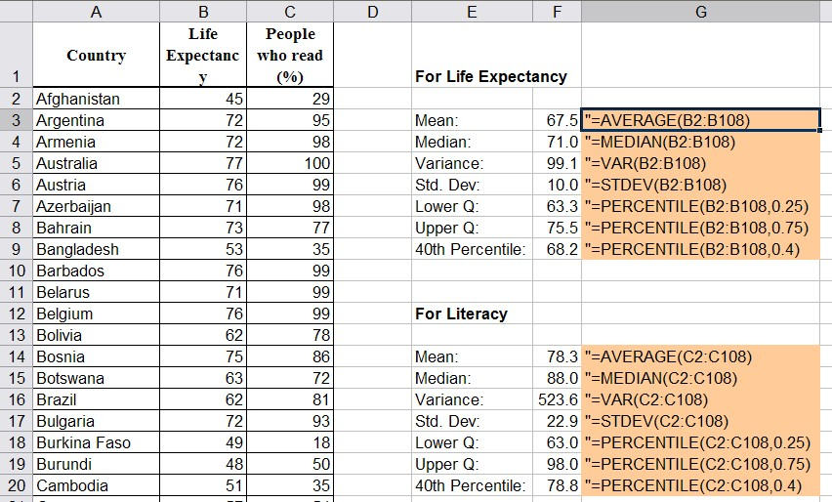
To find the relative ranking (aka percentiles) for Japan, the USA, and Afghanistan we use the "percentrank" function where we substitute the life expectancy for the respective countries for x:
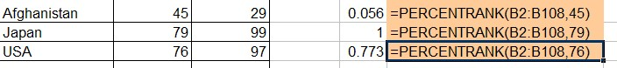
Since these numbers are in percent, we have:
- Afghanistan is at the 5.6th percentile in life expetancy, i.e. about 5% of countries have shorter, 95% have longer life expectancy than Afghanistan
- Japan is at the 100th percentile in life expetancy, i.e. about 100% of countries have shorter, nobody has longer life expectancy than Japan
- USA is at the 77.3th percentile in life expetancy, i.e. about 77.3% of countries have shorter, 22.7% have longer life expectancy than the USA
Example: To practice, use the previous life expectancy data and compute the mean, mode, median, variance, and standard deviation, the max and min values, and the upper and lower percentages.

4.6 Box Plot and Skewed Distributions
By now we have a multitude of numerical descriptive statistics that describe some feature of a data set of values: mean, median, range, variance, quartiles, percentiles, ranks, etc. There are, in fact, so many different descriptors that it is going to be convenient to collect many of them in a suitable graph called the Box Plot.
The Box Plot, sometimes also called "box and whiskers plot", combines the minimum and maximum values (and therefore the range) with the quartiles into one useful graph. It consists of a horizontal line, drawn according to scale, from the minimum to the maximum data value, and a box drawn from the lower to upper quartile with a vertical line marking the median.
It might sound pretty convoluted, so to see how it works it is best to consider an example.
Example: In an earlier example we considered the following cotinine levels of 40 smokers. Draw a box plot for that data.
0 | 87 | 173 | 253 | 1 | 103 | 173 | 265 | 1 | 112
198 | 266 | 3 | 121 | 208 | 277 | 17 | 123 | 210 | 284
32 | 130 | 222 | 289 | 35 | 131 | 227 | 290 | 44 | 149
234 | 313 | 48 | 164 | 245 | 477 | 86 | 167 | 250 | 491
We already computed the lower and upper quartiles to be Q1 = 86.5 and Q3 = 251.5, respectively. It is easy to see that the minimum is 0 and the maximum is 491. A quick computation shows that the median is 170. The corresponding box plot looks therefore as follows:
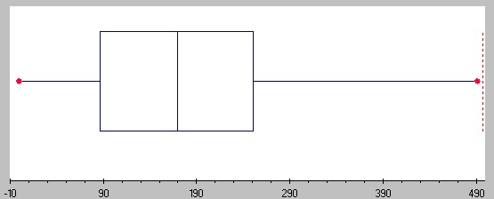
You can see that the horizontal line (sometimes called the "whiskers") goes from 0 to 491 (from min to max), while the box extends from 86.5 (= Q₁) to 251.5 (= Q₃) with a middle vertical line at 170 (the median).

Drawing a Box Plot with Excel
Unfortunately Excel does not have a nice build-in facility to quickly create a box plot. You could of course use the formulas "max(RANGE)", "min(RANGE)" together with "PERCENTILE(RANGE, 0.25)", "PERCENTILE(RANGE, 0.75)" and "median(RANGE)" and then draw a box plot by hand. However, I found an easy-to-use Excel template that is not quite as convenient as the Data Analysis tools we've been using, but should still be pretty simple and useful.
To use the Excel Box Plot template, click on the icon below to download the file:
boxplot.xls
When you open the file, Excel will show you a worksheet with a finished box plot already, and a column on the right in green where you can enter or paste your data. Simply delete the data currently in that column and replace it with your new data to create a new plot. The box plot will update automatically.
Example: Create a box plot for the Life Expectancy by country that we considered before.
We first need to open the Life Expectancy data file - click on the icon below for the data file.
life.xls
When the spreadsheet opens up, mark all numeric data in column B (the Life Expectancy column) but not including the codlumn header and copy them to the clipboard (for example, press CTRL-C). Then open the boxplot.xls spreadsheet and position your cursor to the first data value in column M. Paste the copied data values (for example, press CTRL-V) into that column and the box plot will automatically update itself so that you should see the following picture:
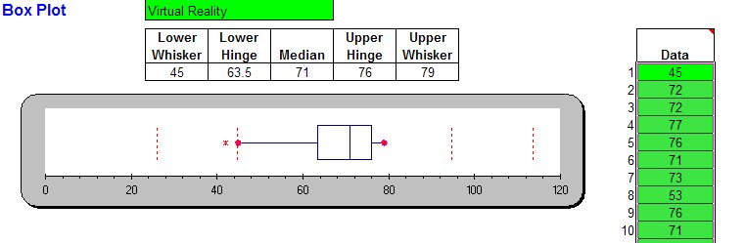
For some data sets you will see some points beyond the max/min value of the whisker. Those points are outliers; they are exceptionally small or large as compared to the rest of the data. Technically these outliers are the max/min, but they would distort the box plot too much. The exact definition of an outlier will be provided below.
Note that the difference between the upper and lower quartile is called the Inter Quartile Range, or IQR. It is used to define outliers (see below).
Example: Find the IQR for the Life Expectancy data above.
We know from the above box plot that the "lower hinge" is 63.5 and the upper hinge is 76. By definition, that means that the quartiles are Q₁ = 63.5 and Q₃ = 76. That makes the Inter Quartile Range IQR = 76 - 63.5 = 12.5

Box Plot and Distributions
In addition to giving you a quick view of the range, the quartiles, and the median, the picture also indicates that if we were to draw a histogram for this data it would look slightly skewed to the left because the box in the box plot is a little towards the right side (yes I know, this looks like a typo but it isn't: a distribution is skewed to the left if the box is on the right side, and skewed to the right if the box is on the left side. In fact, even though the box plot does not directly contain the mean (it only shows the median) it is possible to estimate whether the mean is less than or greater than the median by looking whether the box plot is skewed to the left or to the right.
First, let's look again at histograms and define what we mean by "skewed" histograms (and distributions):
A histogram (distribution) is called  Bell-Shaped or normal  if it looks similar to a "bell curve".  Most data points fall in the middle,  there are few exceptionally small  and few exceptionally large values. | 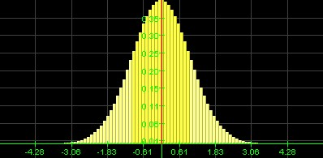  Normal Distribution
A histogram (distribution) is called  skewed to the right  if it looks like a bell curve with a  longer tail on the right and the  mount pushed somewhat to the  left.  Most data points fall to the left of the  middle, there are more small than large values, but there are a few extreme values on the right. | 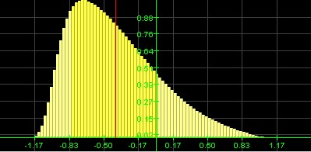  Skewed to the right Distribution
A histogram (distribution) is called  skewed to the left  if it looks like a bell curve with a  longer tail on the left and the  mount pushed somewhat to the  right.  Most data points fall to the right of the  middle, there are more large than small values but there are a few extreme vaues on the left. | 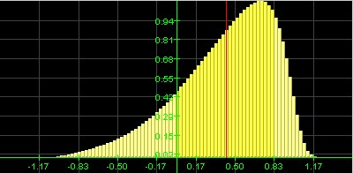  Skewed to the left Distribution
You can tell the shape of the histogram (distribution) - in many cases at least - by just looking the box plot, and you can also estimate whether the mean is less than or greater than the median. Recall that the mean is impacted by especially large or small values, even if there are just a few of them, while the median is more stable with respect to exceptional values. Therefore:
- If the distribution is normal, there are few exceptionally large or small values. The mean will be about the same as the median, and the box plot will look symmetric.
- If the distribution is skewed to the right most values are 'small', but there are a few exceptionally large ones. Those large exceptional values will impact the mean and pull it to the right, so that the mean will be greater than the median. The box plot will look as if the box was shifted to the left so that the right tail will be longer, and the median will be closer to the left line of the box in the box plot.
- If the distribution is skewed to the left, most values are 'large', but there are a few exceptionally small ones. Those exceptional values will impact the mean and pull it to the left, so that the mean will be less than the median. The box plot will look as if the box was shifted to the right so that the left tail will be longer, and the median will be closer to the right line of the box in the box plot.
As a quick way to remember skewedness:
- longer tail on the left means skewed to the left means mean on the left of median (smaller)
- longer tail on the right means skewed to the right means mean on the right of median (larger)
- tails equally long means normal means mean about equal to median>
Example: Here is some (fictitious) data in an Excel sheet for three variables named varA, varB, and varC.
distribution-data.xls
Create a box plot for the data from each variable and decide, based on that box plot, whether the distribution of values is normal, skewed to the left or skewed to the right, and estimate the value of the mean in relation to the median. Then compute the values and compare them with your conjector.
One of the data columns results in the following box plot and interpretation based on it:
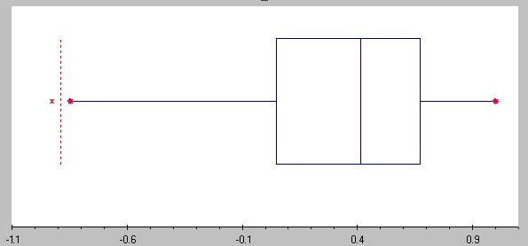
Distribution is shifted to the left, the mean should be less than median (the exact numbers are: mean = 0.3319, median = 0.4124).

The other data column has the following box plot and interpretation based on it:
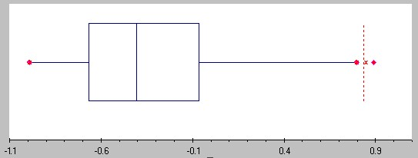
Distribution is shifted to the right, the mean should be greater than the median (the exact numbers are: mean = -0.3192, median = -0.4061)
The final data column has the following box plot and interpretation based on it:
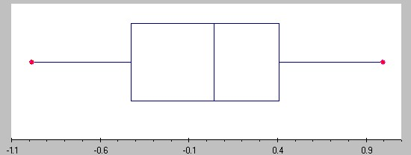
Distribution is (approximately) normal, mean and median should be similar (the exact numbers are: mean = 0.013 median = 0.041)
Unfortunately I forgot to write down which of these cases correspond to varA, varB, and varC - can you figure it out -:)

Box Plot, Outliers, and Standard Deviation
We have seen that even though the box plot does not explicitely include the mean, it is possible to get an approximate idea about it by comparing it against the median and the skewness of the box plot:
- if the distribution is skewed to the left, the mean is less than the median
- if the distribution is skewed to the right, the mean is bigger than the median

In a somewhat similar fashion you can estimate the standard deviation based on the box plot:
- the standard deviation is approximately equal to the range / 4
- the standard deviation is approximately equal to 3/4 * IQR
Both estimates work best for normal distribution, i.e. distributions that are not skewed, and the first approximation works best if they are no outliers. We will later determine additional relations between the standard deviation for normallydistributed data.That reminds me: another useful application for the IQR is to define outliers:
- outliers are data points that fall below Q₁-1.5*IQR or above Q₃+1.5*IQR
Example: Consider the above data on cotinine levels of 40 smokers. Find the IQR and use it to estimate the standard deviation. Also, identify any outliers.
The data ranges from 0 to 491 (from min to max), while the Q1 = 86.5 and Q3 = 251. Thus, we have two estimates for the standard deviation:
- s is approximately equal to range / 4 = 491 / 4 = 122.75
- s is approximately equal to 3/4 * IQR = 0.75*(251-86.5) = 123.375
The estimate is pretty close and since the true standard deviation is 119.5, they are both pretty close to the actual value. The best part of these estimates is, however, that they are so very simple to compute and thus they give you a quick ballpark estimate for the standard deviation.
As for any outliers, they would be data values:
- above Q₃ + 1.5*IQR = 251 + 1.5 * 164.5 = 497.75: none
- below Q₁ - 1.5*IQR = 86.5 - 1.5 * 164.5 = -160.1: none
So there are no outliers in this case (which is one reason why the estimate of range/ 4 works prertty well).
Example: Find all outliers for the life expectancy data above.
For that data set we found that IQR = 76 - 63.5 = 12.5 and therefore outliers woukd be data values:
- above Q₃ + 1.5*IQR = 76 + 1.5 * 12.5 = 94.75
- below Q₁ - 1.5*IQR = 63.5 - 1.5 * 12.5 = 44.75
Thus, the three data points for Uganda (42), Cent. Afri. R (43), and Tanzania (43) are outliers below, while there are no outliers above. Note that since there are outliers, the range/4 estimate for the standard deviation should not work as well as the estimate based on the IQR. Confirm that!

4.7 Descriptive Statistics in Excel
Excel provides a convenient tool to compute many of the most commonly used descriptive statistics such as mean, mode, median, variance, and standard deviation all at once.
Example: The following Excel spreadsheet contains some data about life expectancy and literacy rates in about 100 countries of the world in 1995. Compute the mean, mode, median, variance, standard deviation, and range of the two variables.
Life Expectancy Data
First, as usual, we need to load the data into Excel. The spreadsheet should look similar to the following:
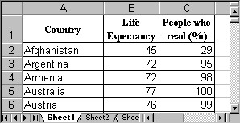
To compute a variety of descriptive statistics all in one swoop, we proceed as follows:
- Select "Data Analysis ..." from the "Tools" menu entry and select "Descriptive Statistics":
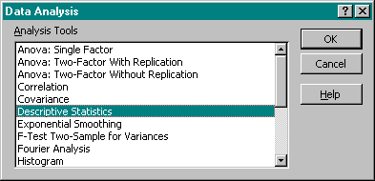
- Enter the Input Range for the data, i.e. place the mouse over column B, click and hold the mouse button, then drag the mouse over column C as well. Both columns B and C should now be selected. Make sure there is a checkmark next to "Summary Statistics" in the "Output Options".
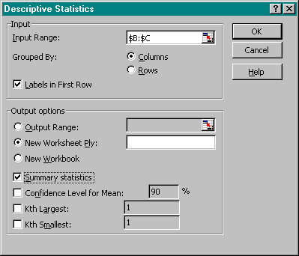
Make sure that you also check the box "Labels in First Row", then click on "OK".
- After clicking on "OK", Excel will compute a variety of descriptive statistics all at once and display them in a new worksheet, as follows:
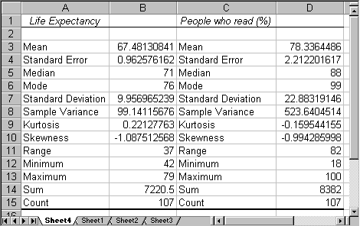
We can see, for example, that for the average "Life Expectancy" we have computed the mean to be 67.48, the median to be 71, and the mode to be 76. The standard deviation is 9.96, the variance is 99.14 and the range is 37.
These descriptive statistics computed by Excel are familiar, and Excel computes a number of additional values such as range, minimum, etc., that are self-explanatory except for "Kurtosis" and "Skewness". We will ignore Kurtosis, but we actually know how to interpret skewness:
- If the skewness is negative, the histogram (distribution) for the data is skewed to the left
- If the skewness is positive, the histogram (distribution) for the data is skewed to the right
- If the skewness is approximately zero, the histogram (distribution) for the data is symmetric and usually normal
Example: Compute the descriptive statistics for the data set
distribution-data.xls
that we analyzed in the previous section about box plots and skewed distributions, and compare the skewness coefficient with the results of your analysis in the previous section.
Loading that data set into Excel and running the "Descriptive Statistics" for all three columns simultaneously yields:
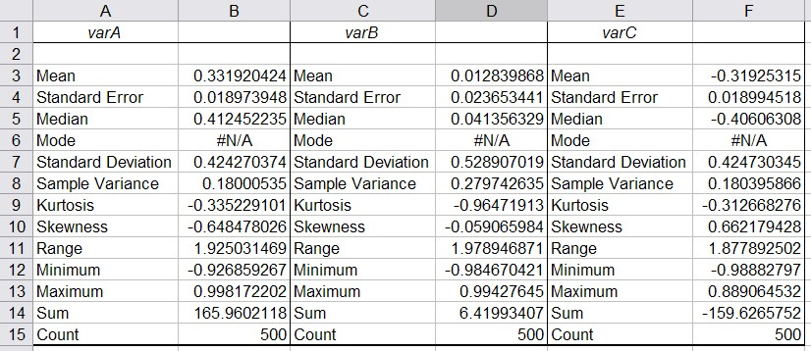
- You can see that "varA" has a negative skewness of -0.65. Thus, the histogram for varA should be skewed to the left and the mean should be smaller than the median. Thus, the first box plot in our previous analysis corresponds to varA.
- "varB" has a skewness close to zero so that its distribution should be normal and mean and median should be similar. Thus, the third box plot from the example in the previous section corresponds to varB.
- "varC" has a positive skewness so the distribution would be skewed to the right and the mean should be greater than the median. Therefore the second box plot from our earlier example describes varC.

