Percentage Tables and Cross Tabs
By Dr. Justin Bateh, Florida State College at Jacksonville &
Dr. Bert Wachsmuth, Seton Hall University

5.1 Frequency Histograms for Categorical Variables
Often one would like to know the frequency of occurrence of values for a variable in percent. This is similar to a frequency histogram or table we studied earlier, but a frequency histogram only applies to numerical variables, while the procedure outlines in this section will apply to categorical variables, much like we did in section 3.6 (there we were interested in charts, now we want percentages).
Thus, this chapter re-introduces the Pivot Table tool we already saw in chapter 3.6. This time we will add some more details, but a potion of the section is as before so you might want to review section 3.6. before reading on.
Example: A survey was conducted, asking 474 randomly selected people for their income level. Display a percentage table for the frequencies for all income levels. In other words, compute, in percentage, how many of the 474 people fall in income level 1, how many in income level 2, etc.
As usual, Excel will be just the tool for this job. Load the following spreadsheet into Excel containing the results of this survey:
Selected Employees
After loading this data we see that there is one column of interest, entitled "Salary Level". However, that column represents a categorical variable (ordinal or nominal?) so we cannot compute a frequency histogram. So, we need to learn a new procedure for handling categorical data.
The appropriate tool to create percentage tables for category data is the "Pivot Table ...". Actually, the PivotTable is more flexible than we will need in our course, but it will for sure create the type of tables that we will be interested in. We have, of course, already seen the Pivot table (and chart) tool in 3.6, but now we'll explore a few more options. And, we will, in fact, see that tool again in the next section(s).
The Pivot tool is found as the first button of the "Insert" ribbon: load the above spreadsheet into Excel. Select "PivotTable ..." from the "Insert" ribbon and select the entire data set, all columns and rows.
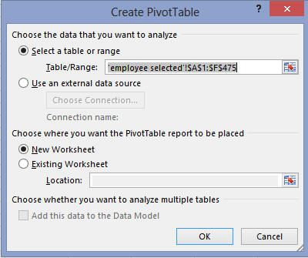
You will see a "potential frequency/percentage table" in a new worksheet, containing labels such as "Drop Row Field Here", "Drop Column Fields Here", etc. There will also be an area for the available variables, in our case "Gender", "Salary Level", "Years of Education", etc. You can "drag-and-drop" these variables to the various slots in the table to create a variety of useful tables for data analysis, or you can drop them into the slots labeld "Columns", "Rows", or "Values" (or, if you want to try, "Filters").
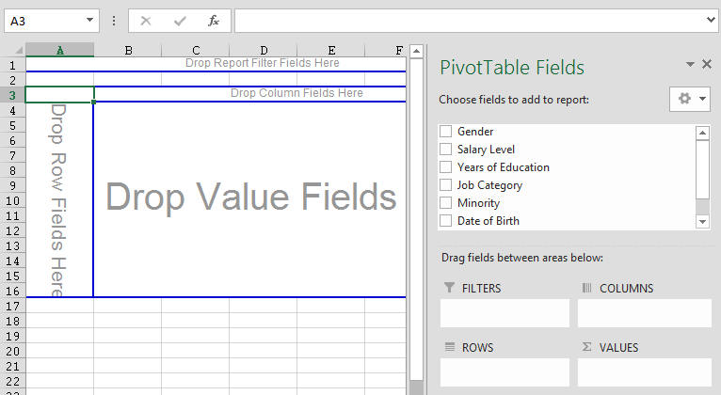
First drag the variable "Salary Level" from the Pivot Fields into the "Drop Row Fields" area of the table. Your table will adjust, showing you all available salary levels. Next, again drag the variable "Salary Level" again, but this time drag it to the "Drop Data Item" area in the middle (or to the "Values" area on the right. You will then see the counts of how many occurrences fell inside each salary level, similar to the following:
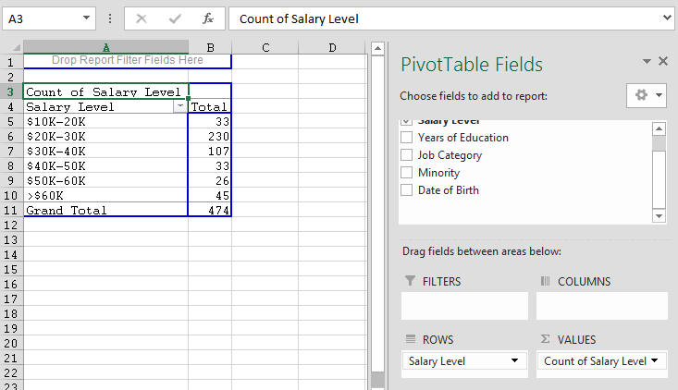
Note that your picture might look slightly different. Make sure, though, that you see two "buttons", one called "Salary Level" (which applies to the first column) and "Count of Salary Level" (which should apply to the second column). We see, for example, that there were 33 people in the salary range of $10K to 20K, 230 in the next salary range, and so forth. Of course raw numbers are not so useful, so we would like to convert them to percentages.
You can adjust what exactly is shown in the "data" area of your table by double-clicking the link entitled "Count of Salary Level" that you see above -Note that you do need to double-click "Count of Salary Level", not "Salary Level". You will see the following dialog:
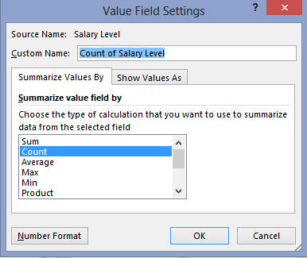
Here you can specify what computation you want to show in the data area of your table. In most cases, Count is the preferred selection, but you do need to change the format for the count. Click the "Show Values as" tab and select "% of Column Total", as shown:
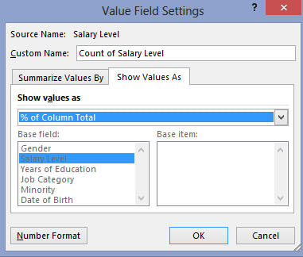

Hit OK and you should see our complete frequency chart for the ordinal variable "salary level":
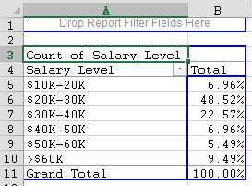
From the table we can see, for example, that 6.96% + 48.52% = 55.48% of employees earn $30,000 or less.
Example: Use the same Excel data set to find the percentage of males and females that took part in this survey, as well as the percentage of the various job categories.
The procedure is similar to above:
- Choose to insert a new "PivotTable ..."
- Select the appropriate column as input
- Put that variable in the "row" as well as the "data" field of the table in the wizzard's dialog box
- Choose the "% of Column Total" option for the "data"
- "Finish" the tables
Here are the resulting tables so that you can check your own results:
- Percentages of male/females in the survey
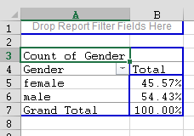

- Percentages of job categories in the survey
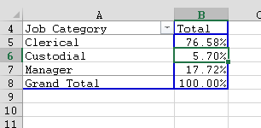
Note: Once you have such a table - Excel calls it a Pivot Table - you can change the categories (variables) to be displayed by dragging them in and out of the table. Maybe you could try to experiment to create a percentage table relating salary level with gender (sex), i.e. work with two variables simultaneously.

5.2 Percentage Tables
So far we have analyzed data one variable at a time. We have seen how to compute mean, mode, median, and variance, but each formula only applied to one variable at a time. Now we want to investigate two (or more) variables simultaneously. Usually, a typical question about two variables is:
Is there some relation between one variable and another one, and if so, how can one use knowledge about one variable to predict, approximately, the other.
Answers to such questions can be very useful:
- if smoking causes cancer, we should stop smoking
- if having an advanced college degree increases the chance to have a well-paying job, we should try our best to graduate college
- if exercising and working out increases our general state of health, we should exercise and work out regularly
- if a new drug really does have a positive impact on lowering blood pressure, we should take it if we have high blood pressure
In most cases the "if" part is the difficult one to determine, i.e. it is not so easy to find out whether two variables (for example smoking and cancer) are indeed related, and even if they are related, it is even harder to determine which is cause and which is result (if smokers have higher cancer rates, does smoking cause cancer, or does having cancer cause you to smoke). In general, correlation does not necessarily imply causation. Here are two examples of incorrectly infering causation from correlation (see http://en.wikipedia.org/wiki/Correlation_does_not_imply_causation):
- The more firemen fighting a fire, the bigger the fire is observed to be. Therefore firemen cause an increase in the size of a fire.
- Sleeping with one's shoes on is strongly correlated with waking up with a headache. Therefore, sleeping with one's shoes on causes headaches.
But let's start at the beginning. We will start our investigation about relationships between variables by taking a closer look at representing data in tables. We won't worry about correlation or causation for now.

Example: The residents of Green Township were asked what their opinion about a new Zoning Ordinance was. The answers were broken down by age of the people who were questioned. The result of the survey is summarized in the following table:
 | age  50 or under | age  over 50 | Total
For Zoning | 92 | 87 | 179
Against or no opinion | 158 | 75 | 233
Total | 250 | 162 | 412
This table can, of course, be entered into Excel directly, and using a few tools that Excel provides the data entry and formatting is quick and effortless.
- First, let's enter the "raw" data, i.e. all data that is actually collected as opposed to computed data. Our spreadsheet will look similar to this:
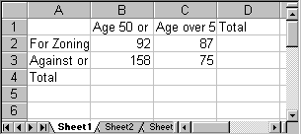
Note that some labels may not be completely visible - we will rectify that later automatically.
- Next, we will asked Excel to compute the totals for us "on the fly". Excel provides a very convenient button for that on the "Home" ribbon: the "Auto Sum" button . Position the cursor in the cell for the first row total and press "Auto Sum" . Excel will indicate the cells that it is going to sum up, which should be all cells to the left (of course you could also enter the "=sum()" formula and pick the range manually, but the 'auto sum' tool is quicker in this case).
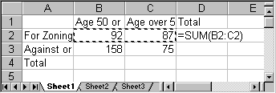
- Press ENTER to accept the choice and Excel will automatically compute the total and enter it in the appropriate cell.
- Keep on using the "Auto Sum" button until all totals are computed. In other words, each time position the cursor first in the cell that will contain the sum, then press "Auto Sum", then press ENTER.
- You can optionally format your table to make it look nice. Select "Format as Table" on the "Home" ribbon and pick a format you like. Here is the final table, nicely formatted (with all labels visible):
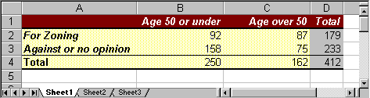
If your table does not look like this it is fine, but it should contain the appropriate row and column totals.

Row and Column Percenta
The above table looks nice, but is not very helpful. It is not meaningful, for example, to know that 92 people age 50 or under are for zoning. What would be useful, of course, would be to know percentages instead of actual figures. So, to better analyze the data we will convert each number to percent. However, for each entry there are three possible percentages to compute:
- we could use a row total to convert a number into percent (row percentages)
- we could use a column total to convert a number into percent (column percentages)
- we could use the grand total to convert a number into percent (total percentages)
Row and column percentages are the most useful, and we will first show how to generate each of them, then discuss when to use which.
Let's convert each number into the appropriate row percentages, i.e. we will use the row total to convert a number into percent:
First, we will copy the original table to a new location just below it:
- select all cells from the table
- choose "Copy" from the "Edit" menu
- position the cursor in the first column a few cells below the original table
- select "Paste" from the "Edit" menu.
A second copy of the original table will appear.
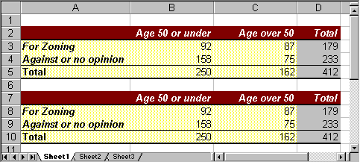
At this point you have a choice:
- you could convert the numbers to percentages "by hand" (well, by hand would mean using a regular calculator)
- you could convert the numbers to percentages using Excel
Excel would do the computations for you, of course, but in this case the power of Excel might actually be overkill. So, we will first convert the figures by hand, using a normal calculator, and then - as an appendix for the Excel enthusiast - we'll show how to use Excel if you insist.

Converting to Row Percentage
In cell B8 the 'raw data' is 92, indicating that there were 92 people age 50 or under who were 'for' zoning. The total in row 8 is 179, indicating that a total of 179 people were 'for' zoning. Thus, the row percentage of people 'for' zoning who are age 50 or under is
92 / 179 = 0.514 = 51.4%
Thus, 0.514 (or 51.4%) of those people 'for' zoning were age 50 or under, and therefore we manually enter the number 0.514 into cell B8, replacing the original value of 92.
Similarly, in cell C8 the raw data is 87, which we convert into row percentage as follows
87 / 179 = 0.486
Thus, 0.486 (or 48.6%) of those people 'for' zoning were over 50 years of age, so we manually enter the number 0.486, replacing the value of 87.
We repeat similar calculations to turn all of the raw data in rows 9 (dividing by 233) and 10 (dividing by 412) into row percentages, and we replace the row totals by 1 (or 100%). Our converted table should look like this, showing the converted numbers but not in percentages:
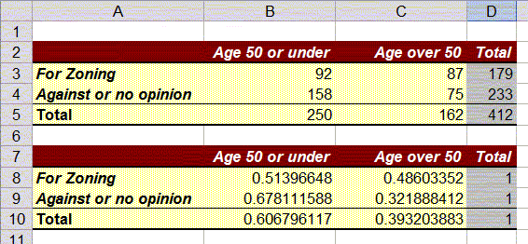
Finally, it is simple to get Excel to format the numbers in cells B8:D10 as percentages:
- Mark the cells containing the ratios in the second table (B8 to D10)
- Click the "%" symbol on the "Home" ribbon, or choose "Percentage" from the drop down menu in the "Number" group.
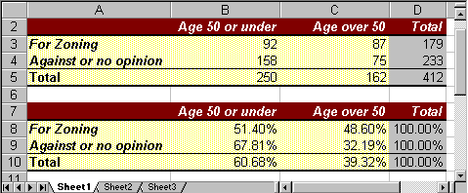

Converting to Column Percentage
Similarly, we can create a third table, containing column percentages. The details are left as an exercise, but for the calculations we need to convert the raw data values by dividing by the column totals instead of the row totals. If we do everything correctly our three tables (properly formatted) should look like this:
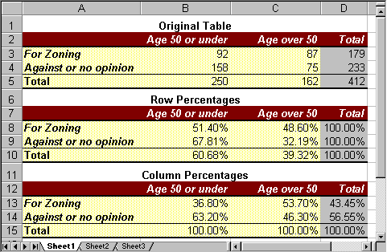

When to use Row Percentages, when Column Percentages
Now that we know how to create either row or column percentages, let's try to determine when to use which. For that, consider two similar but very much different questions:
- How many people, in percent, who are for the zoning law are age 50 or under?
- How many people, in percent, 50 or under are for the zoning law?
These questions seem similar: we are looking at the intersection between the row "For Zoning" and the column "Age 50 or under". From the first table we know that 92 people fall into that category, but that number is not in percent. On the other hand, there are two candidates for the percentage number, 52.4% from the row percentages or 36.8% from the column percentages. Which one answers which question ?
- Question 1 asks, rephrased: out of all people who are for the zoning law, how many of them are age 50 or under. In other words, question 1 considers all people who are for the zoning law as a total - that is a row total, so that the answer to question 1 is the row percentage 51.4%.
- Question 2 asks, rephrased: out of all people who are 50 or under, how many of them are for the zoning law. In other words, question 2 considers all people who are 50 or under as a total - that is a column total, so that the answer to question 2 is the column percentage 36.8%.
From that example we see that the key to answer questions such as these is which group is considered the "total" group for the particular question:
- if the total for that group is found in a row, use row percentages
- if the total for that group is found in a column, use column percentages
It seems that generating these percentage tables is a fair amount of work. Of course Excel provides an easier method for generating such tables from actual data, which we will explore soon.

Appendix: Converting to Percentages using Excel
In this case it is simpler doing the proper computations using a regular calculator, but we could use Excel just as well. I recommmend you check out the video below, or follow the step-by-step instructions after that, but the video contaiins a few fun and helpful Excel tricks - you don't want to miss them.
If you prefer written instructions, try these: our starting point is the original table with the raw data values, copied to a second version as in this picture:
Now position the cursor into cell B8 (second table, containing the value 92). We will replace this "raw" value by a computed one as follows:
- type "=" (the equal sign)
- click once in the first table on the value 92 (cell B3)
- type "/" (the division symbol)
- click once in the first table on the value 179 (cell D3)
- hit ENTER
The value 92 in the second table will now be replaced by the appropriate ration 0.5139 (which is not in percent, but do not worry about that right now).
We repeat this calculation for the next cell, C9 (second table, containing the value 87). We compute row percentages:
- type "=" (the equal sign)
- click once in the first table on the value 87 (cell C3)
- type "/" (the division symbol)
- click once in the first table on the value 179 (cell D3)
- hit ENTER
If we keep going this way, we can convert all numbers into row percentages. Actually, all numbers so far will be decimal values, but we can easily format them as percentages as outlined above.
And it should be possible, now, to convert the raw data into column percentages, using Excel - see above for the final tables.
The advantages of this approach is that - while more work than using a calculator - the percentage table(s) will automatically update if the raw data values change if we use Excel formulas.

Practicing
To practice, consider the following table of raw numbers, relating sex (or gender) with puls rate (the numbers are from a survey for this class):
 | low pulse rate | high pulse rate | Totals
Male | 1 | 1 | 2
Female | 9 | 6 | 15
Totals | 10 | 7 | 17

Convert the table into (a) row percentages and (b) column percentages, then use the appropriate figures to answer the following questions:
- How many males (in percent) have a high pulse rate?
  - This is a row percent so the answer (in percent) is: 1 / 2 * 100 = 50%
- how many people (in percent) with a high pulse rate are female?
  - This is a column percent so the answer (in percent) is: 6/7 * 100 = 85.7%

5.3 Crosstabs Tables
In the first part of this chapter we saw how to use Excel's "Pivot" function to compute counts or frequencies for us, using one (categorical) variable at a time. In the second part we saw how to create row and column percentage tables for two categorical variables manually, if we already knew the total counts in the respective categories. Now we want to automatically generate tables involving two variables from a particular data set instead of converting existing tables into percentage tables. The procedure will be similar to the one before, so make sure you are familiar with the previous section.
Example: Attached is an Excel data file listing salary levels and other information about employees of a particular company. Create and interpret tables relating:
- Gender with Salary Level
- Salary Level with Years of Education
- Salary Level with Job Category
Selected Employees
With Excel, the appropriate tool to create such crosstabs tables is - you guessed it - the "PivotTable ..." in the "Insert" ribbon.
- Load the above spreadsheet into Excel
- Click "Insert", then "PivotTable ...", as in the previous section.
- Use the range selector tool to select the entire data set
You will see the table (hopefully) familiar from the previous section, where you can drag variables from the PivotTable Fields into the "Row", "Column", and/or "Values" areas. We won't make use of "Filters".
To analyze the relationship - if any - between "Gender" and "Salary Level", drag the variable "Salary Level" to the "Row" field of the table and the variable "Gender" to the "Column" field (if you accidentally drop a variable in the wrong spot, simply drag it back).
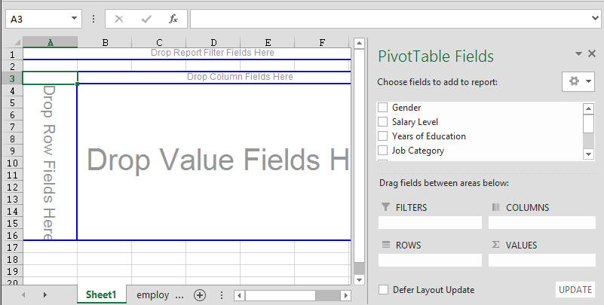
That will create a table with "Salary levels" as rows and "Gender" as columns, but containing no data yet. Finally, drag either "Gender" or "Salary Level" into the "Data" field in the middle (in our case it does not matter which one but in the picture below we used "Salary Level") and the table will be complete - but with raw data, not percentages.
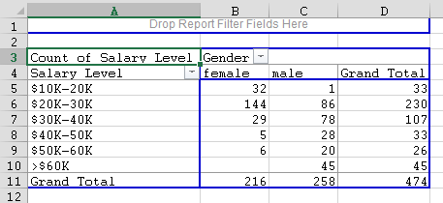
This table shows, for example, that 32 female employees out of 474 total employees earn between $10,000 and $20,000, while, for example, 45 male employees earn more than $60,000.
Similarly, we can create tables to relate "Salary Level" with "Years of Education". We could start again from scratch, but since we already have the pivot table available, we can simply drag the "Salary Level" and "Gender" variables out of the table and drag the "Years of Education" and "Salary Level" to the respective row, column, and data area to create our next table:
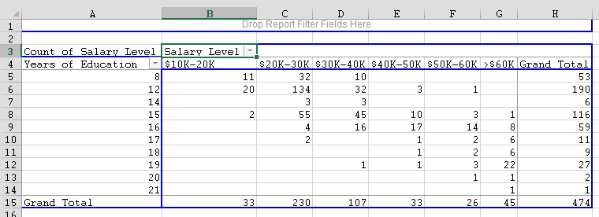
Similarly, we can create the table relating "Salary Level" with "Job Category", but I leave the details up to you. To finish our discussion on crosstabs tables, let's use the above tables to answer specific questions:
Example: Using the same Excel data as before, answer the following questions:
- How many female employees earn less than $40,000 ? How many males ?
- How many people earning more that $60,000 have 15 years of eduation or less ? How many of those have more than 15 years of education ?
All answers should be in percent.
At first glance it might seem that we have already created the right tables to answer these questions. However, this time we want the answers in percent, while our above tables contain actual numbers. And, as we have discussed in the previous section, when we want to generate percentage tables we need to decide whether we want row or column percentages. Therefore, we first need to discuss exactly which tables to generate to answer these questions before worrying about how to do it in Excel.
To answer question 1, we clearly need to generate a table relating salary with gender. Let's use salary as row variable and gender as column, just as above:
Question 1 uses as total all female employees, and in our table the "females" go along a column. Therefore, we need to generate column percentages in the above table.
- Double-click the "Count of Salary Level" button in your table and click on "Options" in the dialog that pops up. Then select "% of column" in the "Show Values As" field and click OK.
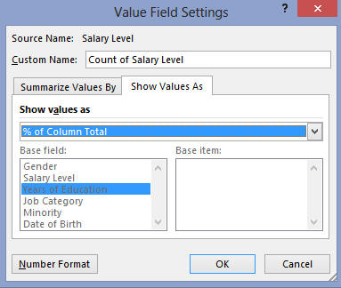
You should see the final table, containing column percentages, as shown below. Note that you can see that the table shows column percentages since the percentages accross the columns add up to 100%.
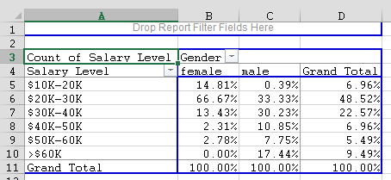
Now we can answer question 1 easily: Recall the question was "how many female employees earn less than $40,000". In the female column we need to add the numbers: 14.81% + 66.67%+13.43% since everyone in those corresponding cells is female and earns less than $40,000. You could of course use Excel to add these numbers, or simply add them in your head. The answer to the question is: 94.91% of females earn less than $40,000. For the male employees, the answer is: 63.95% of males earn less than $40,000.
Actually, this seems to indicate that female employees, as a rule, earn less money than male employees. We will learn how to answer questions such as these in the next section.
It is left as an exercise to answer the second set of questions "How many people earning more than $60,000 have 15 years of education or less ? How many of those have more than 15 years of education". Here are, for your information, the answers (recall that you first need to determine whether to use row or column percentage tables, which of course depends on your choice of row and column variables, as well as on the particular question. Here is a particular table we chose to create:
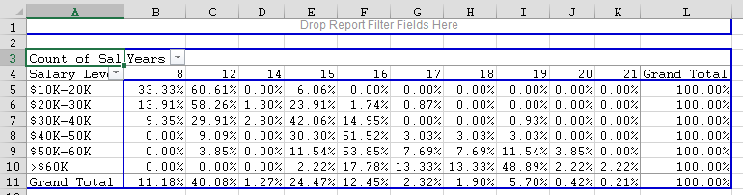
By rthe ways, is that table using row or column percentages ? The correct answers are:
- 2.22% of people earning more than $60,000 have 15 years or less of education
- 97.78% of people earning more than $60,000 have more than 15 years of education
Again, a more interesting question would be to determine whether more years of education generally result in higher salaries (it does looks that way) - we will answer that type of question in the next section.

5.4 Chi-Square Test for Crosstab Data
In the previous section we computed crosstab tables, relating two categorical variables with each other. A natural question to ask now is:
Is there a relationship between two (categorical) variables, or do they appear to be independent?
The complete answer to this question would take us into the realm of hypothesis testing, which we have not yet introduced. For example, what exactly do we mean by "independent". But the question is intuitively easy to understand, so we will give a brief discussion on how to answer the above question without covering all of the mathematical details.
Example: Consider the crosstabs table we generated before, relating income with sex for a particular company, using the data file Selected Employees. The table we generated (using the Pivot Table as desribed previously) with raw numbers, not row or column percentages, looked as follows:
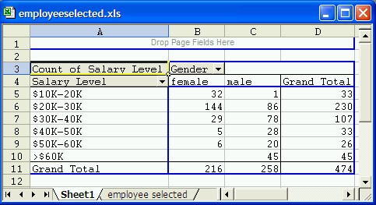
A natural and interesting question is: "Is there a relationship between salary and sex (the row and column variables) or do the two variables appear to be independent of each other".
To answer this question we assume at first that the row and column variables are independent, or unrelated. If that assumption was true we would expect that the values in the cells of the table are balanced.
Actual versus Expected - the Theory
To determine what we mean by balanced, let's take a simple example with two variables, sex and smoking, for example. We are interested in figuring out whether there is a relation between sex (male/female) and smoking (yes/no), or whether the two variables are independent of each other. We therefore conduct an experiment and ask a randomly selected group of people for their sex and whether they smoke. Then we construct the corresponding crosstabs table. Let's say we get a tables as follows (the actual numbers are fictitious):
 | Male | Female | Totals
Smoking | 30 | 5 | 35
Not smoking | 10 | 55 | 65
Totals | 40 | 60 | 100

Of the 35 people that are smoking, 30 of them are male. Conversely, of the 65 people that are not smoking, 55 of them are female. Such an outcome - using common sense - would suggest that there is a relation between smoking and sex, because the vast majority of smokers is male, while the majority of non-smokers is female.
On the other hand, we might have gotten a table like this (again with fictitious numbers):
 | Male | Female | Totals
Smoking | 22 | 18 | 40
Not smoking | 26 | 34 | 60
Totals | 48 | 52 | 100
Now the smokers and non-smokers are divided pretty much evenly among men and woman, suggesting perhaps that the two variables are independent of each other (a person's sex does not seem to have an impact on their smoking habit).
Now let's look exactly how a balanced table should look like if we assume that two variables are indeed independent. Suppose we are again conducting our experiment and select some random sample, but for now we only look at totals for each variable separately (the actual numbers are once again fictitious). Suppose, for example:
- number of smokers is 30, number of non-smokers is 70
- number of males is 40, number of females is 60
- total number of data values (subjects) is 100

With this information we could construct a crosstabs tables as follows:

 | Male | Female | Totals
Smoking |  |  | 30
Not smoking |  |  | 70
Totals | 40 | 60 | 100

But what kind of distribution in the various cells would we expect if the two variables were independent?
- We know that 30 of 100 (30%) are smoking; there are 40 males and 60 females - if male and female had nothing to do with smoking (the variables were independent) that we would expect that 30% of the 40 males are smoking, while 30% of the 60 females were smoking.
- We also know that 70 of 100 (70%) are not smoking; there are 40 males and 60 females - if the two variables were independent, I would similarly expect that 70% of the 40 males were not smoking and 70% of the 60 females were not smoking
Under the assumption of independence I would expect my table to look as follows:
 | Male | Female | Totals
Smoking | 30/100 * 40 = 12 | 30/100 * 60 = 18 | 30
Not smoking | 70/100 * 40 = 28 | 70/100 * 60 = 42 | 70
Totals | 40 | 60 | 100

In other words, if a crosstabs table with 2 rows and 2 columns has a row totals r₁ and r₂, respectively, and column totals c₁and c₂, then if the two variables were indeed independent we would expect the complete table to look as follows:
 | X | Y | Totals
A | r_{1 *} c₁ / total | r_{1 *} c₂ / total | r₁
B | r_{2 *} c₁ / total | r_{2 *} c₂ / total | r₂
Totals | c₁ | c₂ | total
But now we can create an effective procedure to test whether two variables are independent:
- Create a crosstabs table as usual, called the actual or observed values (not percentages)
- Create a second crosstabs table where you leave the row and column totals, but replace the count in the i-th row and j-th column by:
(total of row i) * (total of column j) / (overall total)
Fill in all cells in this way and call the resulting crosstabs table the expected values table, because these numbers would beexpected in this position of the table if the two variables under investigation were indeed independent. Now, here is the clue:
If the actual values are very different from the expected values, the conclusion is that the variables can notbe independent after all (because if they were independent the actual values should look similar to the expected values).
The only question left to answer is "exactly when is this diffence too large", i.e. at which point can I assume that the difference between expected and actual values is so large that I have to conclude that the variables cannot be independent. Before we answer that question, let's return to our original example.

Actual versus Expected Values
Recall that we wanted to determine whether sex (gender) and salary level are independent of each other based on the particular company studied. According to our theoretical discussion above, we create a second table with the same number of rows and columns (and labels) and name that table "Expected Values", while the original table will be named "Actual Values". We simply copy-and-paste the original table and erase the "inside cells" so we can recompute them (do not copy the very top line of the original table).
Note that the table with actual values must contain counts, not percentages
In the table of expected values, each entry is computed as the:
product of the row and column total for that cell, divided by the overall total
The next picture illustrates these computations:
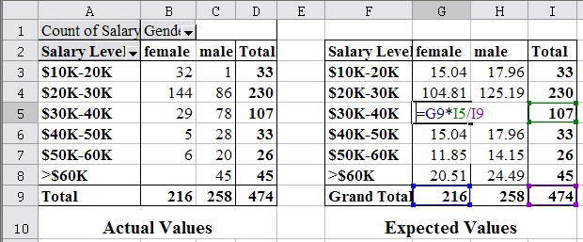
For example, the entry in cell G5 (column G, row 5) of the Expected Values table is the product of the column G total (cell G9) times the row 5 total (cell I5) divided by the overall total (cell I9). Similarly, the entries of the other expected values are:
Value of cell G3 = G9 * I3 / I9 | Value of cell H3 = H9 * I3 / I9
Value of cell G4 = G9 * I4 / I9 | Value of cell H4 = H9 * I4 / I9
Value of cell G5 = G9 * I5 / I9 | Value of cell H5 = H9 * I5 / I9
... | ...
If we compare the values, we see that of the people making $60K or more, fewer than expected are female (0 versus 20.51) while more than expected are male (45 versus 24.49). On the other hand, in the low-income category of $10-$20K, more than expected are female (32 versus 15.04) while fewer than expected are male (1 versus 17.96). That seems to point towards a gender bias for salaries, i.e. women make less money than men as a rule, or to phrase it differently:
the row and column variables do not seem independent of each other; so that there seems to be a dependence between them
In other words:
- if the sum of differences^{(*)} between actual and expected values is "small", the assumption of independence is valid
- If the sum of differences^{(*)} between actual and expected values is "large", the assumption of independence is invalid, hence there must be a relation between the variables
The big question left is: when is the difference small enough to accept the independence assumption, and when is the difference so large that we can no longer assume independence and must therefore accepted dependence. The answer to this question is provided by the Chi-Square test.
(*) We don't really need the sum of differences, because then negatives and positives would cancel each other out. Instead, we square all differences before adding them up to eliminate possible negative signs. Fortunately, though, Excel will handle the details of our computation.

The Chi-Square Test
The Chi-Square test computes the sum of the differences between actual and expected values (or to be precise the sum of the squares of the differences) and assign a probability value p to that number depending on the size of the difference and the number of rows and columns of the crosstabs table.
- If the probability value p computed by the Chi-Square test is very small, differences between actual and expected values are judged to be significant (large) and therefore you conclude that the assumption of independence is invalidand there must be a relation between the variables. The error you commit by rejecting the independence assumption is given by this value of p.
- If the probability value p computed by the Chi-Square test is large, differences between actual and expected values are not significant (small) and you do not reject the assumption of independence, i.e. it is likely that the variables areindeed independent.
To compute the value of p, use the Excel function
=chisq.test(actual_range, expected_range)
Important Restriction: The Chi-Square test is not appropriate if any of the expected values are less than 5. Excel willnot check this restriction - you need to manually inspect the expected values to ensure none of them have a value of less than 5.Let's call this the Rule of Thumb test.
Now we can finish the above example: we used the Selected Employees data to generate the crosstabs table:
First we copy this table of actual counts to a second table (IMPORTANT: DO NOT COPY THE TOP ROW OF THE TABLE) to another table and compute the expected values as outlined above:
Please not that all expected values are bigger than 5 (the smallest expected value is 15.04), so the Chi-Square test is applicable. Thus, in an empty cell, enter the Chi-Square test function:
=chisq.test(B3:C8, G3:H8)
In the above case Excel computes that value to p = 1.91E-22, which is scientific notation for 0.00000000000000000000191. Thus, p is most definitely small and hence we conclude that there is a relation between the two variables sex and salary. In other words, the salary level in this particular company does depend on the sex of the employees. Since p is so close to zero our error is close to zero as well, so we are pretty certain that our conclusion is correct.

Example: Using the data from Selected Employees, is there a relation between salary and years of schooling?
We first use the data and the Pivot Table tool to create a crosstabs table of salary versus years of schooling, as in the previous section:
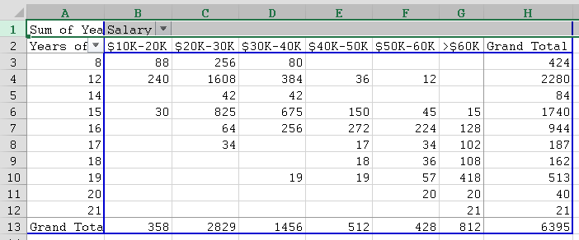
Next we copy this table (without copying the top row) and paste it below the actual table. Then we compute the expected values, which is a lot of work. Finally, we compute the Chi-Square test value p:
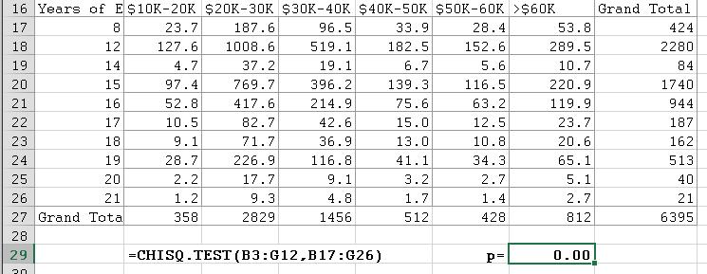
Again the value of p is for all intent and purposes zero, so we can with high certainty conclude that there is a relation between years of education and salary level (in other words, based on this data you make more money with more years of education, just like your parents told you).
BUT we failed to check if the expected values pass our "rule-of-thumb" test! In fact, several of the expected values are small, certainly smaller than 5. Thus, in this case the Chi-Square test is not reliable and we should not believe its conclusions since the assumptions of the test were not satisfied! To remedy the problem, you could re-categorize the data by using fewer groups so that hopefully the expected values in the new tables will all be above 5
So, here is a final example.
Example: Every year there are large-scale surveys, selecting a representative sample of people in the US and asking them a broad range of questions. One such survey is the General Social Science (GSS) survey from 1996 (which contains mostly categorical data). Use the data (which is real-life data from 1996) to analyze if there is a relation between party affiliation and people's opinion on capital punishment.
After downloading and opening the GSS96-selected.xls data file, we construct a crosstabs table for "Party Affil" and "Capital Punishment" as described in previous sections, using the Pivot Table.
Then we copy the table (of actual values) to a second table and construct the expected values as described above (this time the table is pretty small, so computing the expected values is not that much work).
Finally, we use the chitest Excel function to compute the value of p. Here are the resulting figures:
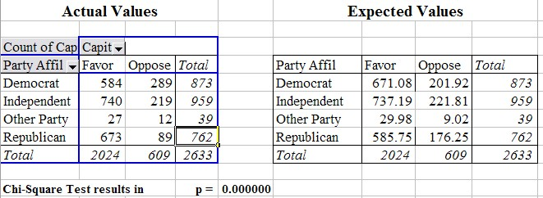
This time the smallest expected value is 9.02, which is above 5 so that it is valid to apply our Chi-Square test. Again p is very close to zero, stating that there is a relation between party affiliation and opinion on capital punishment. In fact, if you compare the actual versus expected values for the Democrats you can see that fewer democrats than expected favor the death penalty, while more than expected oppose it. For Republicans it is just the other way around. For independent and people with other party affiliations there seems to be little difference between actual and observed values.
So far in all our examples the variables were dependent (probably). Of course that is not always the case. For example, if we setup the corresponding tables for actual and expected values for the data from the GSS96 survey relating "Life is" with opinion on "Capital Punishment", we see that the computed p value is p = 0.045, which means that if we did reject the assumption of independence and hence stated that the outlook on life and the opinion on capital punishment are related, we would make an error of 4.5% - that might be more than we are willing to accept (see figure below).
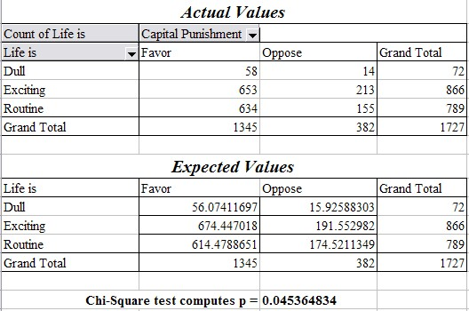
Finally, note that the Chi Square Test for crosstabs tables, as described here, checks whether two variables are independent of each other or not. If the test results in our conclusion that two variables are related, then the next question is: how strong are they related. There are different statistical procedures that allow you to decide about the strength of a relationship, but for categorical data Excel does not provide the necessary functions to quickly perform these necessary computations.
To analyze the strength of a possible relation between two variables we will restrict ourselves to numerical variables and move on to the next chapter.

