Relations Between Variables
By Dr. Justin Bateh, Florida State College at Jacksonville &
Dr. Bert Wachsmuth, Seton Hall University

6.1 Correlation between Variables
In the previous section we saw how to create crosstabs tables, relating one variable with another, and we computed the Chi-Square statistics to tell us if the variables are independent or not. While this type of analysis is very useful for categorical data, for numerical data the resulting tables would (usually) be too big to be useful. Therefore we need to learn different methods for dealing with numerical variables to decide whether two such variables are related. In addition, the new techniques will allow us to make predictions of future events based on events in the past.
Example: Suppose that 5 students were asked their high school GPA and their College GPA, with the answers as follows:
Student | HS GPA | College GPA
A | 3.8 | 2.8
B | 3.1 | 2.2
C | 4.0 | 3.5
D | 2.5 | 1.9
E | 3.3 | 2.5
We want to know: is high school and college GPA related according to this data, and if they are related, how can I use the high school GPA to predict the college GPA?
There are two answers to give:
- first, are they related, and
- second, how are they related.
Casually looking at this data it seems clear that the college GPA is always worse than the high school one, and the smaller the high school GPA the smaller the college GPA. But how strong a relationship, if any, seems difficult to quantify.
We will first discuss how to compute and interpret the so-called correlation coefficient to help decide whether two numeric variables are related or not. In other words, it can answer our firstquestion. We will answer the second question in later sections. First, let's define the correlation coefficient mathematically.
Definition of the Correlation Coefficient
If our data is given in (x,y) pairs, then compute the following quantities - stay with me, the formulas might look pretty intense but when we'll see the exmaples the formulas should become crystal clear:
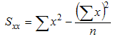
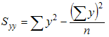
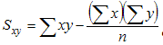
where the "sigma" symbol indicates summation and n stands for the number of data points. With these quantities computed, the correlation coefficient is defined as:
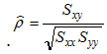
These formulas are, indeed, quiet a "hand-full" but with a little effort we can manually compute the correlation coefficient just fine.
To compute the correlation coefficient for our above GPA example we make a table containing both variables, with additional columns for their squares as well as their product:
Student | HS GPA  (x) | College GPA  (y) | x² | y² | x*y
A | 3.8 | 2.8 | 3.8² = 14.44 | 2.8² = 7.84 | 3.8*2.8 = 10.64
B | 3.1 | 2.2 | 3.1² = 9.61 | 2.2² = 4.84 | 3.1*2.2 = 6.82
C | 4.0 | 3.5 | 4.0² = 16.00 | 3.5² = 12.25 | 4.0*3.5 = 14.00
D | 2.5 | 1.9 | 2.5² = 6.25 | 1.9² = 3.61 | 2.5*1.9 = 4.75
E | 3.3 | 2.5 | 3.3² = 10.89 | 2.5² = 6.25 | 3.3*2.5 = 8.25
Sum | 16.7 | 12.9 | 57.19 | 34.79 | 44.46
The last row contains the sum of the x's, y's, x-squared, y-squared, and x*y, which are precisely the quantities that we need to compute S_{xx}, S_{yy}, and S_{xy}. Thus, we we can compute these quantities as follows:
- S_{xx} = 57.19 - 16.7 * 16.7 / 5 = 1.412
- S_{yy} = 34.79 - 12.4*12.4 / 5 = 1.508
- S_{xy} = 44.46 - 16.7 * 12.4 / 5 = 1.374
Therefore, the correlation coefficient for this data is:
1.374 / sqrt(1.412 * 1.508) = 0.9416

Interpretation of the Correlation Coefficient
The correlation coefficient as defined above measures how strong a linear relationship exists between two numeric variables x and y. Specifically:
- The correlation coefficient is always a number between -1.0 and +1.0.
- If the correlation coefficient is close to +1.0, then there is a strong positive linear relationship between x and y. In other words, if x increases, y also increases.
- If the correlation coefficient is close to -1.0, then there is a strong negative linear relationship between x and y. In other words, if x increases, y will decrease.
- The closer to zero the correlation coefficient is, the less of a linear relationship between x and y exists
In the above example the correlation coefficient is 0.9416 which is very close to +1. Therefore we can conclude that there indeed is a strong positive relationship between high school GPA and college GPA in this particular example.

Using Excel to computer the Correlation Coefficient
While the table above certainly helps in computing the correlation coefficient, it is still a lot of work, especially if there are lots of (x, y) data points. Even using Excel to help compute the table seems like a lot of work. However, Excel has a convenient function to quickly compute the correlation coefficient without us having to construct a complicated table.
The Excel built-in function
=CORREL(RANGE1, RANGE2)
returns the correlation coefficient of the the cells in RANGE1 and the cells in RANGE2. All arguments should be numbers, and no cell should be empty.
Example: To use this Excel function to compute the correlation coefficient for the previous GPA example, we would enter the data and the formulas as follows:
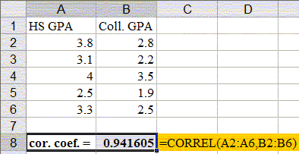

Example:
Consider the following artificial example: some data for x and y (which have no particular meaning right now) is listed below, in a "case A", "case B", and "case C" situation.
Case A:  x = 10, y = 20  x = 20, y = 40  x = 30, y = 60  x = 40, y = 80  x = 50, y = 100 | Case B:  x = 10, y = 200  x = 20, y = 160  x = 30, y = 120  x = 40, y = 80  x = 50, y = 40 | Case C:  x = 10, y = 100  x = 20, y = 20  x = 30, y = 200  x = 40, y = 50  x = 50, y = 100
Just looking at this data, it seems pretty obvious that:
- in case A there should be a strong positive relationship between x and y
- in case B there should be a strong negative relationship between x and y
- in case C there should be no apparent relationship between x and y
Indeed, using Excel to compute each correlation coefficient (we will explain the procedure below), confirms this:
- in case A, the coefficient is +1.0, i.e. strong positive correlation - in fact, in this easy case we can see that linear relation between x and y is y = 2 x
- in case B, the coefficient is -1.0, i.e. strong negative correlation - the actual equation relating x with y is a little harder to see, though
- in case C, the coefficient is 0.069, which is close to zero, so there is no correlation
Note that in "real world" data, the correlation is almost never as clear-cut as in this artificial example.
Example: In a previous section we looked at an Excel data set that shows various information about employees. Here is the spreadsheet data, but the salary is left as an actual number instead of a category (as we previously had).
 Employees (numerical)
Download this file into Excel and find out whether there is a linear relationship between the salary and the years of education of an employee.
Download the above spreadsheet and start MS Excel with that worksheet as input.

Find an empty cell anywhere in your spreadsheet
- Type
=CORREL(
- Select the first input range (corresponding to the salary) by dragging the mouse across all cells containing numbers in the "Salary" column
- Type
,
(a comma)
- Select the second input range (corresponding to the months on the job) by dragging the mouse across the "Years of Education" column containing numbers
- Type
)
and hit RETURN
Excel will compute the correlation coefficient. In our example, it turn out that the correlation coefficient for this data is 0.66
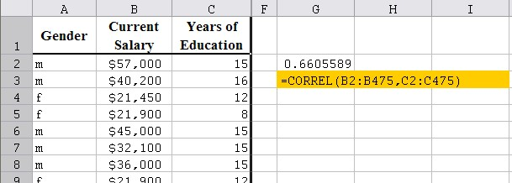
Since the correlation coefficient is 0.66 it means that there is indeed some positive relation between years of schooling and salary earnings. But since the value is not that close to +1.0, the relationship is not strong.
In the next sections we will introduce a more detailed analysis, which will allow us to not only to determine whether or not there is a linear relation, but also to compute the exact equation of that linear relation, which we can in turn use to make predictions. So, I hope that motivates you enough to read on.

6.2 Scatter Plots
So far we have seen how to determine whether two variables are independent (Chi-Square test for categorical variables) or linearily related (correlation coefficient for numeric variables). In this section we will investigate the exact nature of the relationship, if any, graphically.
We will, in particular, look at situations where there is a (suspected) causal relationship where one variable causes particular values of another variable. In other words, we will look at situations where two variables are related in such a way that if one is known the other one can be computed. In such cases, "scatter plots" are a convenient tool to represent both variables and their (possible) relationship.

Dependent and Independent Variables
If there is a relationship between two variables in such a way that knowledge of the first allows the computation or prediction of the second, then the first variable is called the independent variable - usually denoted by x - while the second is called the dependent variable - usually denoted by y.
Note: in practice, the independent variable often refers to a time prior to that of the dependent variable.
Example: A group of 11 students was selected at random and asked for their high school GPA and their freshmen GPA in college the subsequent year. The results were:
Student | High School GPA | Freshmen GPA
1 | 2.0 | 1.6
2 | 2.2 | 2.0
3 | 2.6 | 1.8
4 | 2.7 | 2.8
5 | 2.8 | 2.1
6 | 3.1 | 2.0
7 | 2.9 | 2.6
8 | 3.2 | 2.2
9 | 3.3 | 2.6
10 | 3.6 | 3.0
We would like to know whether there is a (linear) relationship between the high school GPA and the freshmen GPA, and we would like to be able to predict the freshmen GPA, if we know that the high school GPA of another student is, say, 3.4.
Since students go to high school prior to going to college, the high school GPA refers to a time before that of the freshmen GPA. Therefore the high school GPA is the independent variable called x, while the freshmen GPA is the dependent variable called y. That makes sense since it is conceivable that the high school GPA determines the freshmen GPA but not the other way around.
We will see how prediction works in the next section. Right now we simply want to visualize the data to "see" if there is a relationship between the high school and freshmen GPA. With our choice of x and y the above table translates into a series of (x, y) data points:
(2.0, 1.6), (2.2, 2.0), (2.6, 1.8), (2.8, 2.1), (3.1, 2.0), (2.9, 2.6), (3.2, 2.2), (3.3, 2.6), (3.6, 3.0)
We can now plot these points in a standard Cartesian coordinate system and then, hopefully, we will simply see whether there is a relation between x and y or not. Of course, we will use Excel to actually generate the graph for us:
- Start, as ususal, Microsoft Excel, with an empty spreadsheet
- Label the first two columns "High School GPA" and "College GPA", respectively. Don't worry if you can't see the first label in its entirety.
- Enter the data in columns, the high school GPA in the first column, college GPA in the second
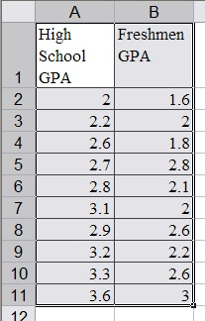
- Use the mouse to mark all data, labels as well as numbers. Then click on the "Insert" ribbon and select "XY (Scatter)" as chart type.
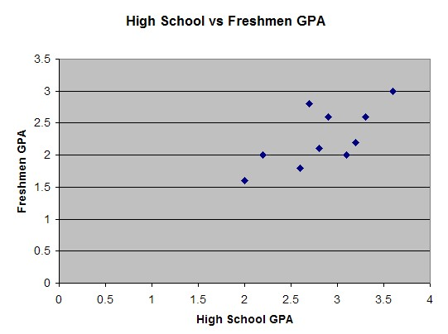
- You can customize the chart to make it look more to your liking. In our case, for example, we can double-click on the "X" axis (horizontal axis) to change the scale so that the minimum value starts at 1.8. We can also click on the "Y" axis (vertical) to change its scale so that it also starts at 1.4. After all, there are no values less than 1, so why not start the axis at that number instead of at zero. Here is a possible final version of the chart (where we have also changed the background color of the chart):
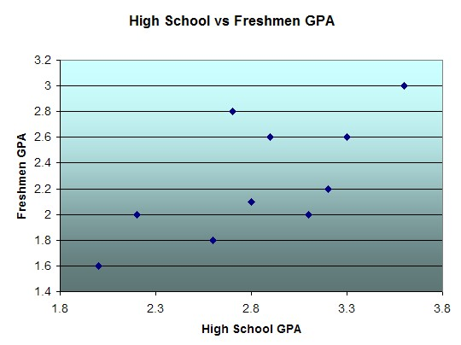
Now that we can "see" the data it seems that there is indeed some loose relationship between high school and college GPA. Generally speaking, low high school GPA's result in low college GPA's, higher high school scores result in better college performance, and in general college grades are somewhat worse than high school grades.
If we did compute the correlation coefficient (from the previous section) is would come out to be 0.69665, confirming that there is some linear relationship between the variables but not a strong one.
In the next section we lean a precise way to determine the linear equation relating x and y and to use the projected relation to make predictions for values that are not part of the original data set.

6.3 Linear Regression
This time we again want to look at data from two variables that are possibly related, but we want to determine the exact nature of that relationship, if any, and develop some formulas that will allow us to make predictions. Let's use the same example that we have used before:
Example: A group of 11 students was selected at random and asked for their high school GPA and their freshmen GPA in college the subsequent year. The results were:
Student | High School GPA | Freshmen GPA
1 | 2.0 | 1.6
2 | 2.2 | 2.0
3 | 2.6 | 1.8
4 | 2.7 | 2.8
5 | 2.8 | 2.1
6 | 3.1 | 2.0
7 | 2.9 | 2.6
8 | 3.2 | 2.2
9 | 3.3 | 2.6
10 | 3.6 | 3.0
We would like to know whether there is a linear relationship between the high school GPA and the freshmen GPA, and we would like to be able to predict the freshmen GPA, if we know that the high school GPA of another student is, say, 3.4. In the previous section we came up with a scatter plot for this data:
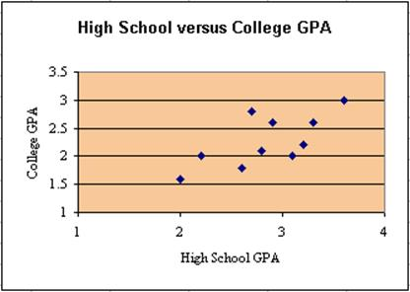
Now we want to fit a straight line through these data points in such a way that the line "fits the data the best". We will specify in a second what we mean by "fits best", but for now let's look at three examples:
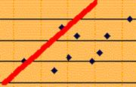  Line 1 | 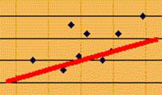  Line 2 | 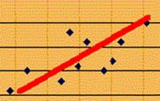  Line 3
In each case we have drawn a line that somehow passes through at least some of the data points. It seems clear that:
- no straight line can pass through all data points exactly
- line 1 does not fit the data points very well because too many points are the the right, or below that line
- line 2 does not fit the data points very well because too many points are above the line
- line 3 does not fit the data points perfectly, but seems to have the best fit of these three lines
Mathematically speaking, the line that gives the "best fit" is that line where the sum of the squares of the differences to all data points has the smallest possible value. Therefore, the line that fits best in that sense is called least-square fit and the process of finding that line is called least-square linear regression.
The actual formulas involved are somewhat complicated, again, since they are based on the expressions S_{xx}, S_{yy}, and S_{xy} we computed while working on the correlation coefficient.

Determining the Least Square Regression Line "manually"
Our goal is to determine the equation of the "least-square regression" line. In other words, we want to find the equation of a line (which happens to be called "least-square regression line"). We know from high school that a line has the equation:
y = m x + b
where m is the slope of the line, and b is the interception of the line with the y-axis. We also recall from high school that lines that go up have a positive slope (as the lines 1, 2, and 3 above), while lines with negative slopes go down.
Example: Suppose we have four equations of lines as follows:
- y = x - 1
- y = 2x - 1
- y = -x + 1
- y = -2x + 1
Moreover, let's say we have four graphs of lines, as follows:
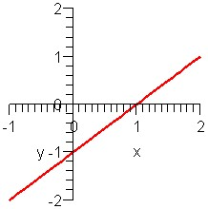  Graph A | 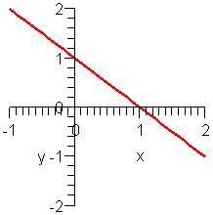  Graph B
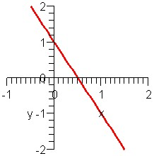  Graph C | 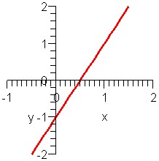  Graph D
Which graph matches what equation?
Solution: According to the equations of the lines, we have the following information:
- y = x - 1 is a line with slope 1 (going up) and y-intercept -1
- y = 2x - 1 is a line with slope 2 (going up) and y-intercept -1
- y = -x + 1 is a line with slope -1 (going down) and y-intercept 1
- y = -2x + 1 is a line with slope -2 (going down) and y-intercept 1
Graphs A and D show lines going up, so both have positive slope. Both also intersect the y-axis at -1, so both have y-intercept -1. But the line in graph D is steeper, so it should have a bigger slope. Thus:
- equation 1matches graph A
- equation 2 matches graph D
Similarly, both graph B and C have negative slopes and y-intercept +1, but line C goes down faster and thus has a more negative slope. Therefore:
- equation 3 matches graph B
- equation 4 matches graph C
So to determine the least-square regression line we must find the equation of a line with its the slope m and y-intercept b. As it happens, the slope is related to our quantities S_{xx}, S_{yy}, and S_{xy} we computed earlier, while the y-intercept is related to the averages (means) of x and y. The formulas are as follows:
- Slope m = S_{xy} / S_{xx}
- y-Intercept b = (mean of y) - (mean of x) * m
where
- mean of x = (sum of x) / n
- mean of y = (sum of y) / n
In this class we are will not try to determine how these formulas come about. That would be done in more advanced math courses. We will be content using these questions, as in our next example.
Example: Consider the above data of high school versus college GPA and compute the equation of least square regression line. Also compute the correlation coefficient.

Solution: just as we did for the correlation coefficient in the first section, we make a table of x, y, x², y², and xy values:
Student | x | y | x² | y² | xy
1 | 2.0 | 1.6 | 4.00 | 2.56 | 3.20
2 | 2.2 | 2.0 | 4.84 | 4.00 | 4.40
3 | 2.6 | 1.8 | 6.76 | 3.24 | 4.68
4 | 2.7 | 2.8 | 7.29 | 7.84 | 7.56
5 | 2.8 | 2.1 | 7.84 | 4.41 | 5.88
6 | 3.1 | 2.0 | 9.61 | 4.00 | 6.20
7 | 2.9 | 2.6 | 8.41 | 6.76 | 7.54
8 | 3.2 | 2.2 | 10.24 | 4.84 | 7.04
9 | 3.3 | 2.6 | 10.89 | 6.76 | 8.58
10 | 3.6 | 3.0 | 12.96 | 9.00 | 10.80
Totals | 28.4 | 22.7 | 82.84 | 53.41 | 65.88
Thus, we can compute:
- S_{xx} = 83.84 - 28.4²/10 = 2.184
- S_{yy} = 54.41 - 22.7²/10 = 1.881
- S_{xy} = 65.88 - 28.4*22.7/10 = 1.412
We also can quickly compute (since we already know the sums of x and of y):
- mean of x = 28.4/10 = 2.84
- mean of y = 22.7/10 = 2.27
But now the difficult work is over and we can compute the slope and y-intercept, as well as correlation coefficient, easily:
- slope m = S_{xy} / S_{xx} = 1.412 / 2.184 = 0.645
- y-intercept b = (mean of y) - (mean of x) * m = 2.27 - 2.84 * 0.645 = 0.4382
- correlation coefficient r = 1.412 / sqrt(2.184 * 1.881) = 0.6966
Thus, the equation of our least-square regression line, relating high school GPA (x) and college GPA (y) is:
- y = 0.645 * x + 0.4382
and the correlation coefficient of 0.6966 indicates that the relation is not very strong.
We can now use our computed equation to make predictions.
Example: Using the above data for high-school and college GPA's, predict the college GPA for a student with a high school GPA of 3.7.
Solution: First note that x = 3.7 is not one of the original high school GPA scores. But we know the general relationship between x and y (the equation of the least-square regression line) which we use for our prediction:
y = 0.645 * x + 0.4382
so that if x = 3.7 we have for y:
y = 0.645 * 3.7 + 0.4382 = 2.8247
Thus, our prediction is that a high school GPA of 3.7 will result in a college GPA of 2.83, approximately. Moreover, because of our correlation coefficient we are relatively confident (but not super-confident) that our prediction is accurate.
This was a lot of work but before we use Excel for the heavy-duty computations, let's do one more example manually.
Example: Suppose some (made-up) data for two variables x and y is as shown in the table. Use that data to predict the yvalue for x = 5 and state how confident you are in your prediction:
x | y
1 | 3
2 | 5
3 | 6
Solution: We create, as usual, a table of x, y, x², ect. data, compute the S_{xx}, etc, and finish up with the equation of the line. Here are the results:
 | x | y | x² | y² | xy
 | 1 | 3 | 1 | 9 | 3
 | 2 | 5 | 4 | 25 | 10
 | 3 | 6 | 9 | 36 | 18
Totals | 6 | 14 | 14 | 70 | 31
- S_{xx} = 14 - 6²/3 = 2
- S_{yy} = 70 - 14²/3 = 4.667
- S_{xy} = 31 - 6*14/3 = 3
We also can quickly compute
- mean of x = 6/3 = 2
- mean of y = 14/3 = 4.667 (it is a coincidence that this value matches the above for S_{yy}.
But now the difficult work is over and we can compute the slope and y-intercept, as well as correlation coefficient, as follows:
- slope m = S_{xy} / S_{xx} = 3/2 = 1.5
- y-intercept b = (mean of y) - (mean of x) * m = 4.667 - 2*1.5 = 1.667
- correlation coefficient r = 3 / sqrt(2*4.667) = 0.982
Thus, the equation of our least-square regression line, relating x and y is:
  - y = 1.5 x + 1.667
Thus, if x = 5 we compute our prediction to be y = 1.5 * 5 + 1.667 = 9.167 and since the correlation coefficient is 0.982 we think that the relation is very strong. Thus, we are pretty sure about our prediction.
Please note that we are basing our prediction or forecast on only 3 data points. Such a small sample is generally not adequate for good predictions. However, the three points are linearily related, so for better or worse we believe our prediction is good. A more careful analysis of the goodness of our prediction would involve probabilities and is beyond our scope at this time.

Determining the Least Square Regression Line "automatically"
After all this work it should be relating to focus on using Excel to deliver the least-square regression line for us.
- Start Excel as usual and enter the data from the above GPA example
- From the "Tools" menu, select the "Data Analysis ...." menu item and choose "Regression"
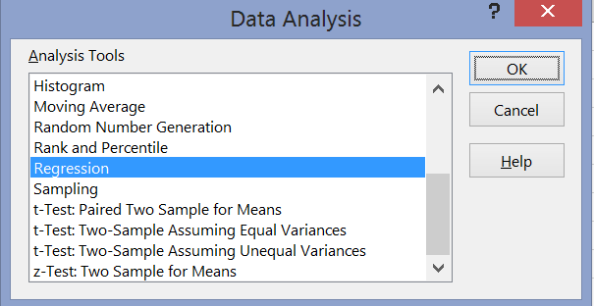

- In the "Regression" dialog window use the selector tools and select the X and Y range (be careful, the first range to choose is the Y range, not X). If you include the labels in the ranges, make sure to check the "Labels" box.
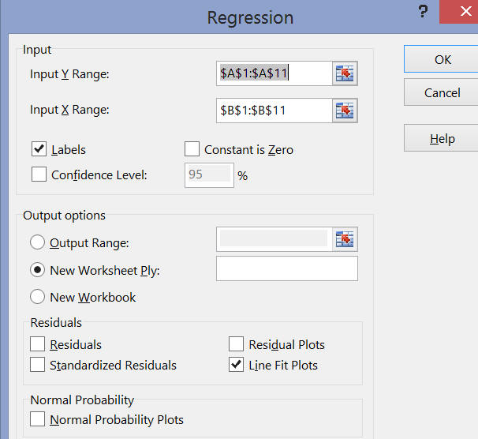
To get a scatter plot including the least-square regression line, make sure to check "Line Fit Plots" in the "Residuals" category. To connect the dots with the least-square regression line, double-click on a pink dot and check "Solid line" on the options on the right side after you generate the regression output.
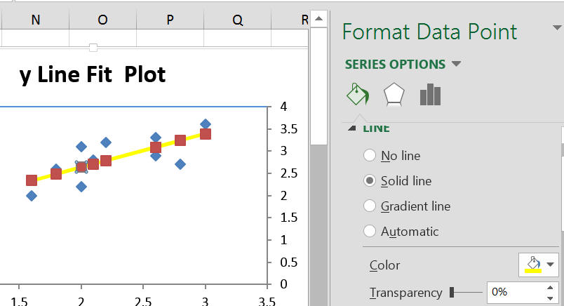
You can, as before, change the x and y axis scale, pick a background color, choose a title, set the line color, modify or remove the markers, etc. Experiment!
The Regression Analsysis actually produces a lot of output, much of it with mysterious sounding names. Here is the interpretation of the most important pieces of the output:
The Chart: includes the scatter plot as before (blue diamond-shaped dots), but also the "predicted" scores (pink rectangluar-shaped dots). If you connect these pink dots you obtain the least-square regression line.
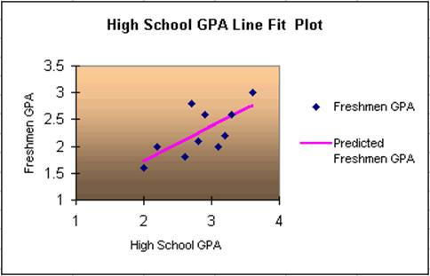
- The Regression Statistics: This statistics is also computed by the regression analysis and looks similar to the following:
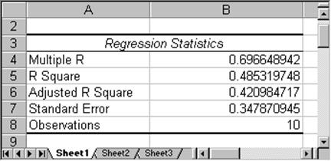
The most important number here is "Multiple R" which has the value of 0.6966 in this case. In fact, that number is almost the same as the "correlation coefficient" introduced earlier. In fact, this "multiple R" is the absolute value of our previous correlation coefficient. Thus, multiple R is always between 0 and 1, and closer to 1 indicates stronger relation. Hence, in this case being resonably close to 1, implies that we can conclude that the two variables are indeed somewhat related. In other words, if the value or "Multiple R" in the "Regression Statistics" is close to 1, then the least-square regression line indeed fits the data points pretty well, and there is a linear (positive or negative) relation between the two variables. It does not indicate which way the relation goes, as the correlation coefficient does.
- The "Anova" Section: The next section produced by our regression analysis is the Anova (Analysis of Variance) section:
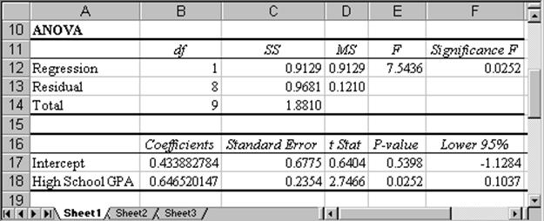
The two most important numbers in this section are the "Coefficients" for the "Intercept" and the "High School GPA". In this case "Intercept" is 0.4339 and "High School GPA" is 0.6465 (rounded). These two numbers are the slope and intercept of the least-square regression line. In other words, the actual equation of the least-square regression line is:
That equation of the line, in fact, can be used for predictions. For example, if we want to know the College GPA (Y) for a student with a high school GPA (X) of 3.4 - or, mathematically speaking, if we want to know the y value when x = 3.4 - we simply substitute x = 3.4 in the above equation and we find the corresponding y value to be.
Note that from this section we see that the slope is positive, which means that the correlation coefficient is also positive. Thus, in this case the correlation coefficient and the multiple R are identical (if the slope had come out negative, the correlation coefficient would be -(multiple R), i.e. it would have been -0.6966).
The "Residual Output" Section: is not important for us in this lecture so we will ignore it.
Now we can also answer the original question: based on our data and a least-square regression analysis of that data, we can predict that a student with a high school GPA of 3.4 will have a college GPA of approximately 2.632. Since the correlation coefficient is 0.69 we are reasonably confident that our prediction is accurate.
Summary of Regression Analysis:
To summarize a typical least-square regression analysis:
- Enter the data in columns in Excel or load an existing data set
- Choose "Regression" from the "Data Analysis ..." menu item in the "Tools" menu
- Select X (independent variable) and Y (dependent variable) ranges and any other options and click on "OK"
- Look at the "Multiple R" value in the "Regression Statistics":
  - if that value is close to -1 or 1, there is a strong linear relationship between X and Y and the least-square regression line will fit the data well
  - if that value is close to 0, the least-square regression line (which is the best line possible) does not fit the data very well
- Write down the equation of the least-square regression line in the form y = mx + b, where m is the slope (from the "Coefficient" column in the last row) and b is the y-intercept (from the the "Coefficient" column in the second-last row labeled "Intercept")
- Use that equation of the least-square regression line to make predictions by substituting the desired x into the equation and computing the corresponding y value. The closer the "Multiple R" value is to 1, the more trustworthy the prediction is. You should always mention the "Multiple R" value when making a prediction. If you want to be sophisticated you should also indicate the value of the correlation coefficient if the slope is negative.
Here is another example, this time with real - and interesting - data:
Example: In the attached Excel spreadsheet you will find data about the literacy rate (percentage of people who read) and average life expectancy of about 100 countries in the world, based on 1995 data. Load that data into Excel and perform a least-square regression analysis to see if there is a linear relationship between the literacy rate and the average life expectancy. If you find that there is a relation, determine what would happen to the life expectancy of people in Afghanistan if the literacy rate could be raised to, say, 60% (from its current value of 29%).
Life
The technicalities of the least-square regression analysis should be clear, so we will simply state and interpret the results: The least-square regression line fits the data quite well, as is clear from the scatter plot:
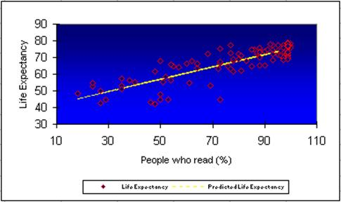
as well as from the value of the correlation coefficient 0.84 which can be found in the "Multiple R" section of the regression analysis output.
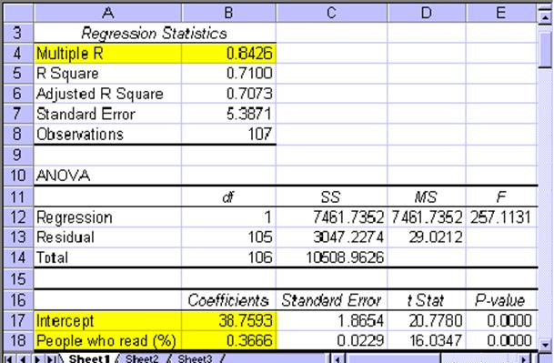
The coefficients of the least-square regression line are 38.7593 (intercept) and 0.3666 (slope) so that the line has the equation:
That means that if a country such as Afghanistan had a literacy rate of 60%, we would predict an average life expectancy of approximately y = 0.3666 * 60 + 38.7593 = 60.7553, or approximately 60 years (as opposed to its current life expectancy of 45 years. Since the correlation coefficient is 0.84 we are in fact quite sure that this prediction is accurate.
Note: This does not mean that reading books causes people to live longer. After all, at the beginning of analyzing two variables we mentioned that correlation does not necessarily imply causation. But what it does mean is that if a country can raise its literacy rate, probably through a wide variety of programs and policy decisions, then a beneficial side effect seems to be that the average life expectancy goes up proportionally as well. It also means that if a country - perhaps for political reasons - does not make its life expectancy rate public, but its literacy rate is known, we can give a pretty good estimate of that life expectancy based exclusively on the literacy rate of the country.

