Sample Questions about Chapter 4 (Part 2)

You should carefully read through chapter 4 and understand the following concepts:

- Measures of Central Tendency: Mean, mode, median
- Measures of Variability: Variance, standard deviation, range
- Percentiles: Lower and Upper Quartile, general Percentile
- The Box Plot and its interpretation

In particular, you should know what the difference is between mean and median, what the standard deviation tells you about a distribution, how to read a box plot to decide whether the corresponding distribution is skewed, etc.

Please work through the following questions BEFORE you take the "Chapter 4 Part 2". I will soon post an answer key to these questions so you can compare your answers. Note that you have already done some of the questions below (the ones related to chapters 4.1 to 4.3), but they are repeated here for your convenience.

Q1: Consider the following data: 8, 9, 7, 8, 4, 2, 4, 2, 1, 4. Find all of the following:

a) The mean:

b) The median:

c) The mode:

d) The range:

e) The variance:

- The standard deviation:

Q2: Several football teams - with a total of 350 athletes - have adopted a new exercise procedure in which the athletes can complete most of their work-outs on their own. After a few weeks, the progress of the athletes from one team was tested as follows: A random sample of 36 trainees from that team was selected and asked to exercise on a bicycle ergometer. The exercise capacities of these 36 athletes (in minutes) are recorded below

32 | 36 | 35 | 33 | 34 | 31 | 36 | 34 | 33 | 33 | 34 | 35
20 | 30 | 28 | 23 | 25 | 19 | 30 | 28 | 22 | 25 | 26 | 28
37 | 47 | 42 | 40 | 40 | 37 | 47 | 42 | 38 | 40 | 41 | 44

a) What is the range of the data ? (no Excel)

b) What is the mean for the data? (first by hand, confirm with Excel)

c) What is the median for the data? (first by hand, confirm with Excel)

19 | 20 | 22 | 23 | 25 | 25 | 26 | 28 | 28 | 28 | 30 | 30
31 | 32 | 33 | 33 | 33 | 34 | 34 | 34 | 35 | 35 | 36 | 36
37 | 37 | 38 | 40 | 40 | 40 | 41 | 42 | 42 | 44 | 47 | 47

d) What is the 80th percentile? (first by hand, confirm with Excel)

e) The value 40 is the how many-ieth percentile? (first by hand, confirm with Excel)

- Please construct a relative frequency table for that data, using 7 groups (you may use Excel here)

Q3: There are two symbols denoting the standard deviation, and . What is the difference between the two symbols ? Which one stands for what ? Similarly, there are two symbols for the mean, and . Which one stands for what?

Q4: If you had to find the best measure of central tendency for the data given below, would you use the mean, the mode, or the median? Justify your choice. Then find all three values.

10 | 7 | 3 | 6 | 3241 | 11 | 5 | 2 | 4 | 1 | 9 | 8

Q5: Two experiments have been conducted, and resulted in the following data:

Data A: 0, 1, 1, 1, 4, 5, 6, 9, 9, 9, 10
Data B: 0, 4, 4, 4, 5, 5, 5, 6, 6, 6, 10

Please state "just by looking" which of the two data sets would have the smaller variance. (You do not actually have to compute the variance)

Q6: To answer some questions about clinic treatment times, a designer acquired data from an established clinic in a location similar to the proposed new clinic's location. The treatment times for 16 patients, randomly selected from the clinic's records, are as follows:

 | 21 | 20 | 41 | 23 | 13 | 21 | 24 | 15
 | 26 | 29 | 23 | 12 | 11 | 28 | 22 | 16

a) Find the median, the lower and the upper quartile.

11 | 12 | 13 | 15 | 16 | 20 | 21 | 21
22 | 23 | 23 | 24 | 26 | 28 | 29 | 41

b) Draw a box plot for the above data.

- If you were to draw a frequency histogram for the data, would it be skewed or symmetric? Confirm by using Excel to draw the histogram.

Q7: Interpret the box plot drawn below. What are the median, the quartiles, and the range (approximately)?

Is the distribution from which the data was selected skewed or symmetric? If it is skewed, would the mean be bigger or smaller than the median ?

Q8: For which one of the two frequency histograms below is the mean smaller than the median? (Circle one)

Q9: The number of persons who volunteered to give blood was recorded for each of 6 successive Fridays and is show below.

8 4 2 7 12 12

Find the mean, mode, median, variance, standard deviation, and range for this data.

Q10: If a distribution is heavily skewed, is the mean or the median the best measure of central tendency?

Q11: True/False questions

To compute the median, the data values must be sorted.

To compute the mean, the data values must be sorted

To compute the upper quartile, the data values must be sorted

To compute the variance, you must first compute the range

To compute the standard deviation, you must first compute the variance

If you score in the 99th percentile of the SAT scores, you should be very happy

If you score in the 30th percentile, it means that 70% of data values are bigger than your data value

If you know that the upper quartile is 75, then 25% of all data values are less than 75.

Q12: Which one of the two frequency histograms has the smaller standard deviation? (Circle one)

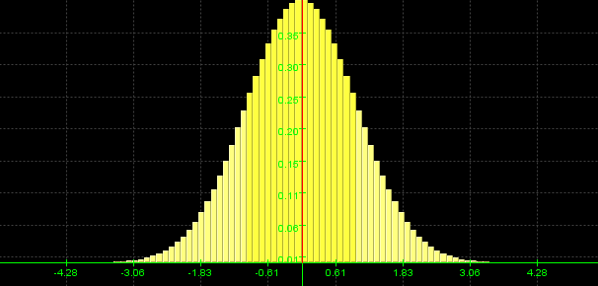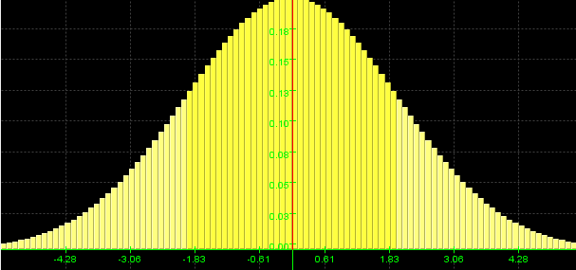

Q13: Which of the following two distributions is skewed to the right?

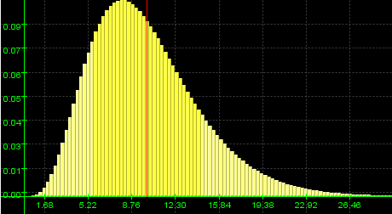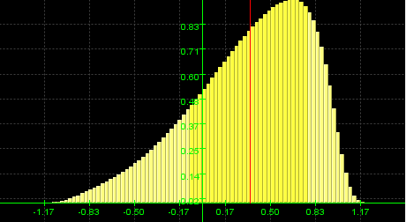

Q14: Suppose you summarized the result of a survey as follows:

. | Are you left or right handed?

 | N | Percent | Valid  Percent
Left Handed | 11 | 9.9% | 9.9%
Right Handed | 95 | 85.6% | 85.6%
Ambixtertrous | 5 | 4.5% | 4.5%
Missing | 0 | 0.0%

Does it make sense to compute the standard deviation? If so, do it. What about

No, this is a nominal variable, and standard dev. does not make sense for those types of variables
Do you play video games on your computer?

 | N | Percent | Valid  Percent
Frequently | 10 | 9.0% | 9.0%
Sometimes | 31 | 27.9% | 27.9%
Not really | 70 | 63.1% | 63.1%
Missing | 0 | 0.0%

If it makes sense now, compute the standard deviation. Here is does make sense, but only if you add codes to the values. The codes are somewhat arbitrary, so we picked 1, 2, 3 to get:

 | N | Code |  | code*N^2
 | N | Code | Code*N | code*N^2
Left Handed | 11 | 1.00 | 11 | 11
Right Handed | 95 |  | 190 | 380
  2.00
Ambixtertrous | 5 | 3.00 | 15 | 45
Totals | 111 |  | 216 | 436

Thus, to find the variance we compute 1/n-1 * (sum_codes^2-sum^code/n) =
= 1/110 * ( 418 – 216 / 111 ) = 0.142506

Therefore the standard deviation s = sqrt(0.142506) = 0.3775

Q15: The survey that you and your fellow students took for the past several years asked for the math portion of the SAT scores. The data is summarized in the table:

 | Frequency | MidPoint | freq * code | freq * code^2
300-390 | 7
391-480 | 17
481-570 | 40
571-660 | 29
661-750 | 8

Find the mean, median, and mode of the math portion of the SATs (we actually already did that) as well as the variance and standard deviation. Also find the 25th and 75th percentile.

This time it is a little different. Instead of an (arbitrary) code we must compute the midpoint of each of the intervals. Using that, and its square, multiplied by the frequency in that row give you a bunch of numbers. We arrange everything in our familiar table like this:

From | To | Frequ. | Midpoint | N*Mid | N*Mid^2 | % | Cum %
300 | 390 | 7 | 345 | 2415 | 833175 | 6.93 | 6.93
391 | 480 | 17 | 435.5 | 7403.5 | 3224224 | 16.83 | 23.76
481 | 570 | 40 | 525.5 | 21020 | 11046010 | 39.60 | 63.37
571 | 660 | 29 | 615.5 | 17849.5 | 10986367 | 28.71 | 92.08
661 | 750 | 8 | 705.5 | 5644 | 3981842 | 7.92 | 100.00
 |  | 101 |  | 54332 | 30071619 | 100

Note that we added the last two columns, with present and cumulative percent, to get an easy handle on the questions:

Median = category 3 (481 – 570) (third category)
Mean = 54332/101 = 537
Mode = category 3 (481 – 570) (third category)
Q1 = 3rd category (first time above 25%)
Q3 = 4th category (first time above 74%
Variance = 1 / 100 * (30071619 – 54332^2/101) = 8442
Std dev = sqrt(8442) = 91.89

Q16: Open the data file at http://www.mathcs.org/statistics/datasets/normtemp.xls (by CRTL-click on the link). Find the variance and standard deviation for the variable Temp (Body Temperature of healthy human) and for the Beats variable. Construct a box plot. What is the IQR? Is the distribution symmetric or skewed left or right? Are there any outliers?

Variance for temp = 0.538
Std Dev for temp = 0.733
Q1 = 97.8
Q3 = 98.7
IQR = 0.9
Outliers: data points less than Q1 – 1.5 * IQR = 97.8 – 1.5*0.9 = 96.45 and above Q3 + 1.5*IQR = 100.5
There are two data points below 94.65, namely 94.3 and 94.5 and one point above 100.5, namely 100.8. Thus, there are 3 outliers.
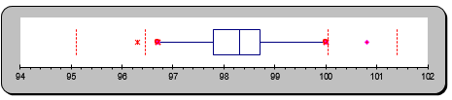
Note that in this box plot there are 3 outliers. 2 on the left (one is barely visible), one on the right. The “adjusted” range is the range of the data minus the outliers.

Variance for beats = 49.87
Std dev for beats = 7.06
Q1 = 69
Q3 = 79
IQR = 10
Outliers would be data values less than Q1 – 1.5 * IQR = 54 or above Q3 + 1.5*IQR = 94. Thus, no data values are outliers.
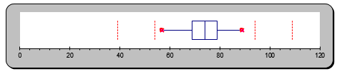
Note that in this box plot there are no outliers.

Q17: In the survey you and your peers took, you ranked several music groups from 0 (terrible) to 5 (incredibly good). Some results are shown below. Which group has the smallest standard deviation?

Elvis
Response | Count | Count * Response | Count*Response^2
0 | 10 | 0 | 0
1 | 10 | 10 | 10
2 | 18 | 36 | 72
3 | 22 | 66 | 198
4 | 27 | 108 | 432
5 | 19 | 95 | 475
 | 106 | 315 | 1187

Variance = 2.39, s = 1.55

 | Beatles
 | Response | Count | Count * Response |  | Count*Response^2
 | 0 | 6 | 0 |  | 0
 | 1 | 5 | 5 |  | 5
 | 2 | 10 | 20 |  | 40
 | 3 | 20 | 60 |  | 180
 | 4 | 28 | 112 |  | 448
 | 5 | 36 | 180 |  | 900
 |  | 105 | 377 |  | 1573

Variance = 2.11, s = 1.45

 | Santana
 | Response | Count | Count * Response | Count*Response^2
 | 0 | 7 | 0 | 0
 | 1 | 11 | 11 | 11
 | 2 | 15 | 30 | 60
 | 3 | 21 | 63 | 189
 | 4 | 27 | 108 | 432
 | 5 | 13 | 65 | 325
 |  | 94 | 277 | 1017

Variance = 2.16, s = 1.47

Pink Floyd
Response | Count | Count*Response | Count*Response^2
0 | 7 | 0 | 0
1 | 10 | 10 | 10
2 | 23 | 46 | 92
3 | 24 | 72 | 216
4 | 11 | 44 | 176
5 | 18 | 90 | 450
 | 93 | 262 | 944

Variance = 2.24, s = 1.49

Thus, the Beatles had the smallest standard deviation, which means that the opinion on the Beatles was somewhat more uniform that for the others.

Q18: Consider the MLB salary data file http://www.mathcs.org/statistics/datasets/MLBPlayerSalaries.xlsx. Which salaries would be considered outliers?

