Chi Square Test for Independence Example
Using Chi-Square, we are looking to see if there is a significant difference between what we would expect results to be, and what the actual results were. That is, expected vs. observed.
Microsoft Excel allows us to determine this.
Listed below are data from a survey conducted recently where Males and Females responded to their job satisfaction on the job (this is fictitious data).
Response | Male | Female | Total
Not at all | 25 | 25 | 50
Somewhat | 16 | 19 | 35
Very | 24 | 15 | 39
Total | 65 | 59 | 124

We are interested in finding out if there is a significant difference in how we expected males to respond and what males actually responded with. Same for females.
We will test this for significance with alpha = .05, meaning we want to be 95% of more confident.
In excel, let’s first calculate the percent of population responses.
Step 1: In excel, let’s first calculate the percent of population responses.
I will take the total responses to Not at all (50), and divide that by the total responses (124) to determine the percentage of respondents in that responded with not at all.
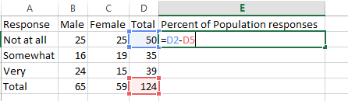
Then, I will do the same for all responses.

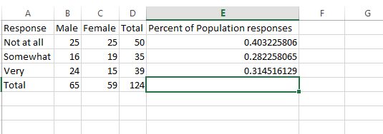
So now we can see that around 40% of the responses were “Not at all”, 28% were “Somewhat” and so forth.
Step 2:
Since 40% of everyone said “Not at all”, we’d expect to see 40% of males say “Not at all”, and 40% of females say “Not at all”, and so forth for the remaining groups.
So we have 65 total males, and if we take the 65 and multiple it by the percent of population responses for “Not at all” which is .0403225806 then we get 26.2 We do the same for female sby multiple 59 times the population percentage for “Not at all”.
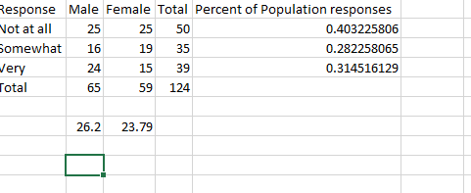
So we what we saying is that we would expect 26.2 males to respond Not At All and 23.79 females to respond not at all. However, our actual results indicate 25 and 25 respectively.
For somewhat and very we will do the same thing.
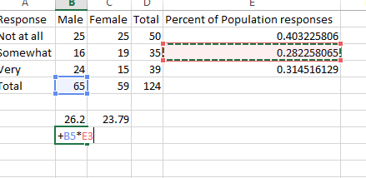

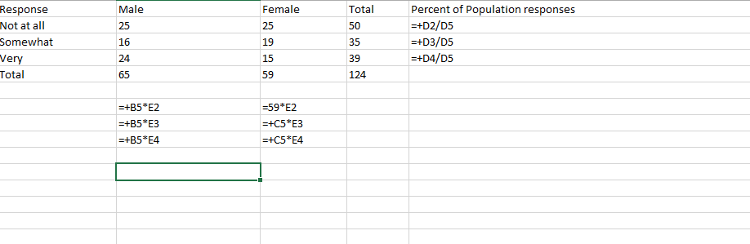
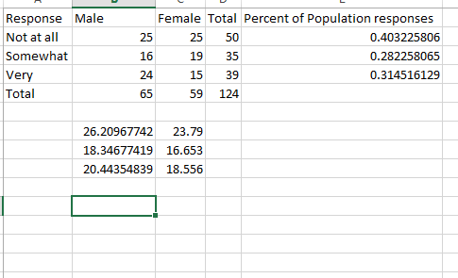

So now we can see what all of our “expected” results should have been, and we can see what our actual results were.
Our null hypothesis is: There is not a significant difference between the actual responses of males and females and the expected responses of males and females.
In Excel, we can run the CHI SQUARE TEST to get our significance variable.
Step 3:
We can use the CHITEST function as shown below, and we are asked to input our actual range and expected range.
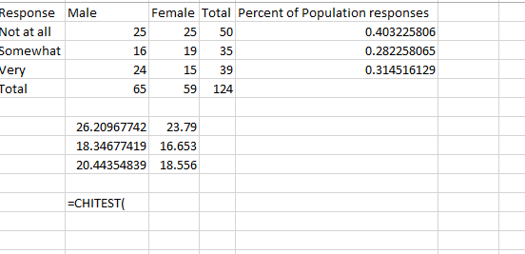
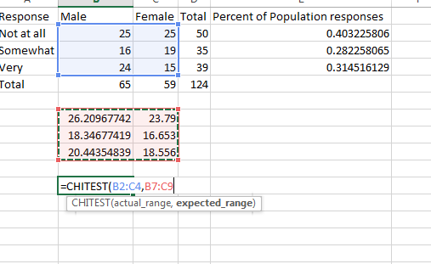
We get a chi square value of 0.35905855
This is much larger than out alpha value of .05 so we fail to reject the null hypothesis and conclude that there is not significance evidence to conclude these male and female actual results are different from the expected results of males and females in the population.

