Solutions:

- In this problem, we are comparing productivity among three difference shifts.
To evaluate the mean differences in three groups we will use analysis of variance (ANOVA)

Following are the steps to perform ANOVA using excel analysis tool pack

From excel menu bar (ribbon) select Data >> Data Analysis

Next, from the popup box select “ANOVA: Single factor” and hit “OK”

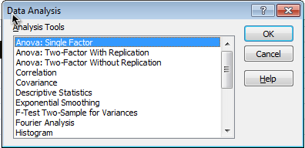

In the new “ANOVA single factor” pop up box, Under the Input section, for “Input Range” select three columns, which contain productivity data for all three, shifts.

Check “Labels in First row” option. Keep alpha at 0.05 level
Check “New Worksheet Ply” under Output options.
Hit “OK”

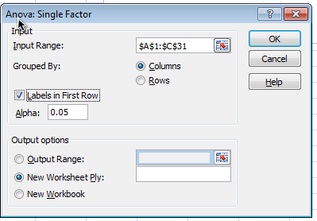

The output will be presented in new worksheet

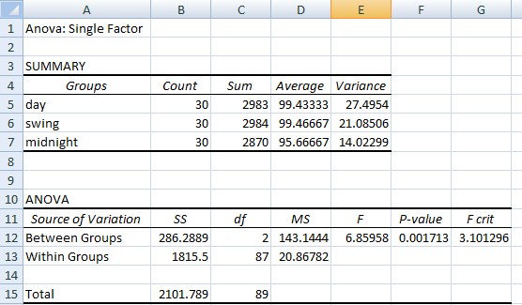

Null hypothesis for the ANOVA in this problem can be given as follows; there is no difference in mean productivity between three shifts. Alternate hypothesis is that at least one shift has mean productivity different from others shifts.

Output for ANOVA shows f-value of 6.8 and p-value =0.002. P-value is less than 0.05, so we reject null hypothesis and conclude that mean productivity of at least one shift is significantly different compared to other shifts.

- MS excel doesn’t provide pairwise comparison results in ANOVA procedure (like other statistical software SAS, SPSS, R etc.)

To determine which shifts has different mean productivity we need compare each shift with other shift using two-sample t-test. Hence, we will make three comparisons using three separate two-sample t-tests.

When we make multiple comparisons (like above), we have to modify the p-value for each t-test, since performing multiple t-tests increases the probability of finding an incorrect significance. To correct it, we will multiply each resulting p-value of t-test with number of total comparisons (i.e. 3 in this problem). This correction is known as ‘Bonferroni correction’

Day shift vs swing shift comparison:

From excel menu bar (ribbon) select Data >> Data Analysis

Next, from the popup box select “t-Test: Two-sample Assuming unequal Variances” and hit “OK”

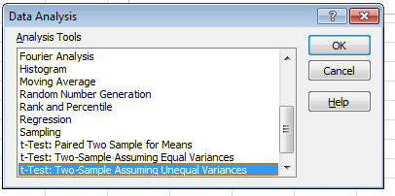

In the new “t-Test” pop up box, Under the Input section, for “Variable 1 Range” select range of cells that has productivity data for “day shift”. Next, for “Variable 2 Range” select range of cells which has productivity data for “Swing” shift.

For “Hypothesized Mean Difference” put “0” value.

Keep “Alpha” value of “0.05” and check “New Worksheet Ply” under Output options.

Hit “OK”
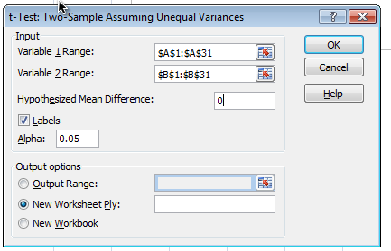

Output for the t-Test will be presented in new worksheet.

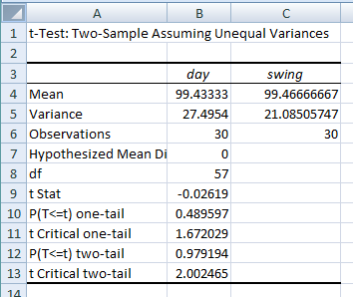

P-value for two-tailed test is 0.97.
Corrected p-value will be greater than, which suggest we fail to reject null hypothesis and conclude that the mean productivity between ‘day’ shift and ‘swing’ shift is not statistically significant.

Day shift vs Midnight shift comparison:

We repeat above steps to perform two-sample t-test between ‘day’ shift and ‘midnight’ shift.
We will select appropriate columns at ‘Variable 1 input’ range and ‘Variable 2 input’ range
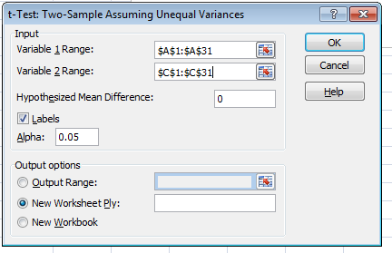

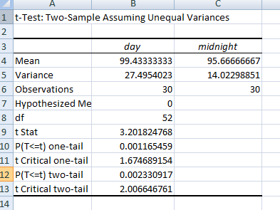

P-value for two-sample t-test = 0.0023
Corrected p-value = 0.0023*3 = 0.0069

The corrected p-value is less than 0.05, so we reject null hypothesis and conclude that there is statistically significant difference between mean productivity between “day” shift and “midnight” shift

Swing vs Midnight shift comparison:

We repeat above steps to perform two-sample t-test between ‘swing’ shift and ‘midnight’ shift.
We will select appropriate columns at ‘Variable 1 input’ range and ‘Variable 2 input’ range
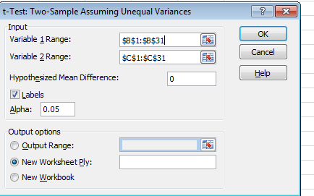

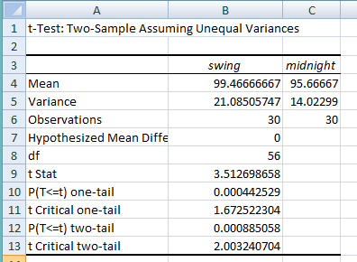

P-value for two-sample t-test = 0.00088
Corrected p-value = 0.00088*3 = 0.00264

The corrected p-value is less than 0.05, so we reject null hypothesis and conclude that there is statistically significant difference between mean productivity between “swing” shift and “midnight” shift

