Solutions:

First, we will copy the ‘study time’ data from MS word to MS Excel.
We will create a new column called ‘study time’ and copy the data in that column

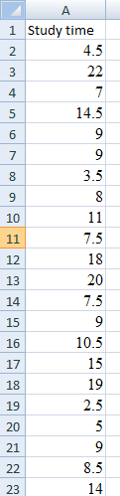

Following are the steps to 95% confidence interval of mean using MS Excel analysis tool pak

From excel menu bar (ribbon) select Data >> Data Analysis

Next, from the popup box select “Descriptive statistics” and hit “OK”

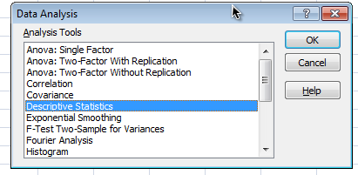

In the new “Descriptive statistics” pop up box, Under the Input section, for “Input Range” select range of cells which has study time for all students.

Check “Labels in first row” option (as header of the column in excel has label for out data)
Check “Summary statistics” and “Confidence Level for Mean”. Keep 95% level (default option) for confidence interval

Hit “OK”

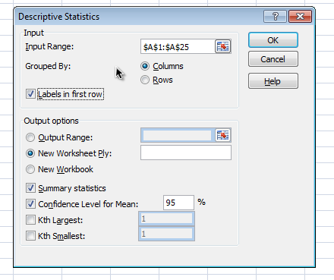

Output for the descriptive statistics will be presented in new worksheet.

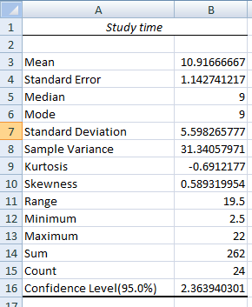

Mean study time among sample student population is 10.91 and margin of error for this data is 2.36 (presented as confidence level (95%)).

Lower limit for 95% confidence level = 10.91 – 2.36 = 8.55
Upper limit for 95% confidence level = 10.91 + 2.36 =13.27

So the 95% confidence level for the mean study time is (8.55, 13.37)

Interpretation of confidence interval:
If we repeat the study (data collection of study times) multiple times, there is a 99 percent probability that the above interval would contain the true mean of study time.

