Solutions:

- Computing correlation coefficient

Following are the steps to compute correlation coefficient using excel analysis tool pak

From excel menu bar (ribbon) select Data >> Data Analysis

Next, from the popup box select “Correlation” and hit “OK”

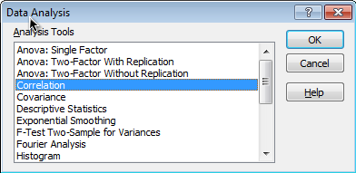

In the new “Correlation” pop up box, Under the Input section, for “Input Range” select “First Weekend”, “US Gross” and “Worldwide Gross” columns.

Select “Columns” in “Grouped By” option

Check “Labels” option.

Check “New Worksheet Ply” under Output options.

Hit “OK”

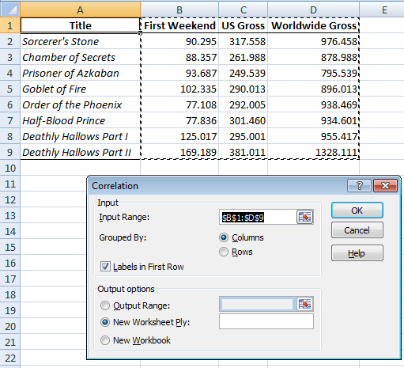

Output for the correlation will be presented in new worksheet.

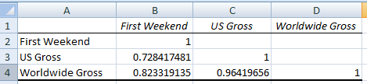

Above output shows correlation coefficient between “First Weekend” gross and “US Gross” was 0.73, between “First Weekend” and “Worldwide Gross” was 0.82 and between “US Gross” and “Worldwide Gross” was 0.96.

- The “Correlation” procedure in “Data analysis” tool pack doesn’t provide p-value for correlation coefficient. To get the p-value for correlation coefficients we will use “regression” option

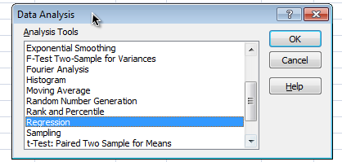

In the new “Regression” pop up box, Under the Input section, for “Input Y Range” select range of cells which has “US Gross” data (including the cell which contain ‘label’). Next, for “Input X Range” select range of cells which has ‘First weekend’
Check “Labels” option.
Check “New Worksheet Ply” under Output options.
Hit “OK”

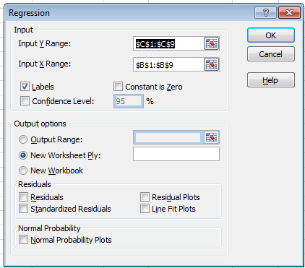

The output will be presented in new worksheet

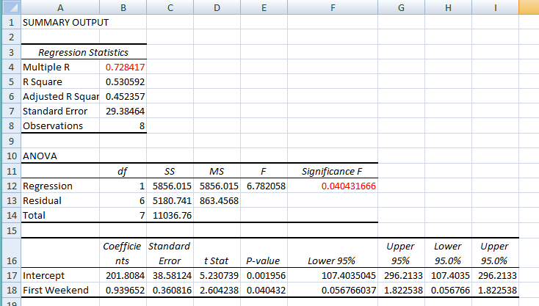

In above output, “Multiple R” shows correlation coefficient between ‘First weekend’ and ‘US Gross’ (0.73) and p-value presented in ANOVA gives p-value for relationship between these two variables. The p-value is 0.04 that is below 0.05, suggesting the relationship between ‘First weekend’ and ‘US Gross’ is statistically significant.

We will repeat the same ‘regression’ procedure for each remaining combination of variables.
Instead of repeating same steps, I am providing just output of regression analysis here.

Relationship between ‘First weekend’ and ‘worldwide gross’

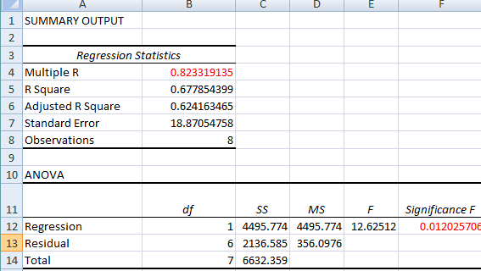

In above output, “Multiple R” shows correlation coefficient between ‘First weekend’ and ‘World wide Gross’ (0.82) and p-value presented in ANOVA gives p-value for relationship between these two variables. The p-value is 0.012 that is below 0.05, suggesting the relationship between ‘First weekend’ and ‘Worldwide Gross’ is statistically significant.

Relationship between ‘US Gross and ‘worldwide gross’
.
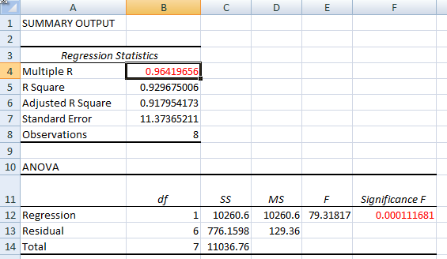

In above output, “Multiple R” shows correlation coefficient between ‘US Gross’ and ‘Worldwide Gross’ (0.96) and p-value presented in ANOVA gives p-value for relationship between these two variables. The p-value is 0.001 that is below 0.05, suggesting the relationship between ‘US Gross’ and ‘Worldwide Gross’ is statistically significant.

- To predict ‘US gross’ for 180 million first weekend gross, we will use output from regression (shown in first part of answer b)

The coefficient for intercept = 201.804

Coefficient for “First Weekend” = 0.939

Predicted US gross for 180 million “First weekend gross” = 201.804 + 180*0.939 = 370.824 million

