Solutions:

- In this study, cholesterol measurements were taken for same set of patient before the intervention and after the intervention. We will evaluate the research question using two sample matched t-test.
Following are the steps to perform two sample matched t-test using excel analysis tool pak

From excel menu bar (ribbon) select Data >> Data Analysis

Next, from the popup box select “t-Test: Paired two sample for means” and hit “OK”

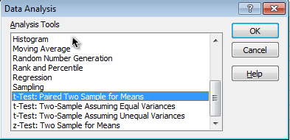

In the new “t-Test” pop up box, Under the Input section, for “Variable 1 Range” select range of cells which has cholesterol levels during ‘Before’ period. Next, for “Variable 2 Range” select range of cells which has cholesterol levels during ‘After’ period.

Set “Hypothesized Mean Difference” put “0” value.

Keep “Alpha” value of “0.05” and check “New Worksheet Ply” under Output options.

Hit “OK”

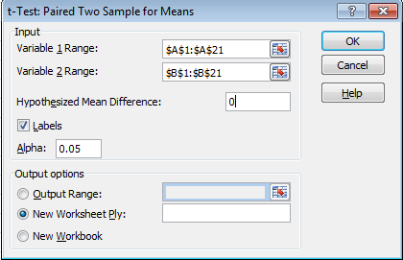

Output for the t-Test will be presented in new worksheet.

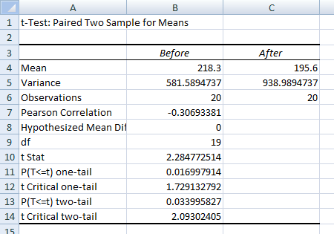

In the research question we are evaluating if the new drug (intervention) was effective in reducing cholesterol level. So, our null hypothesis is that the mean cholesterol level was not reduced from ‘Before’ period to ‘After’ period. In other words, the mean difference in cholesterol levels (‘After’-‘Before) is greater than or equal to zero. Alternate hypothesis is mean difference (‘After’-‘Before) in cholesterol level is less than zero.

Hence, we will be looking at p-value for one-tailed test.

Above output shows that, mean cholesterol level ‘Before’ the intervention was 218.3 and mean cholesterol level ‘After’ the intervention was 195.6. The t-test statistic was 2.28 and p-value for one-tailed test was 0.02.

One-tailed p-value is 0.02 which is less than 0.05 cut off value. So we reject null hypothesis and conclude that mean cholesterol level during ‘After’ intervention period was statistically significantly lower compared to mean cholesterol level during ‘Before’ intervention period.

