Solutions:

To evaluate the difference in two methods of instructions we will use two sample t-test.

Following are the steps to perform two sample t-test using excel analysis tool pack

From excel menu bar (ribbon) select Data >> Data Analysis

Next, from the popup box select “t-Test: Two-sample Assuming Unequal Variances” and hit “OK”

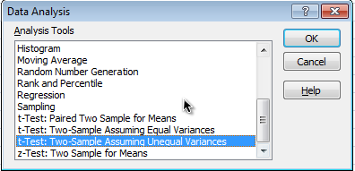

In the new “t-Test” pop up box, Under the Input section, for “Variable 1 Range” select range of cells which has example scores for ‘In Class’ students (including the cell which contain label). Next, for “Variable 2 Range” select range of cells which has example scores for ‘Online’ students.

As our null hypothesis is that the mean exam scores are same among ‘In class’ and ‘Online’ instruction students, the hypothesized mean difference is zero.

So, for “Hypothesized Mean Difference” put “0” value.

Check “Labels” option.

Keep “Alpha” value of “0.05” and check “New Worksheet Ply” under Output options.

Hit “OK”

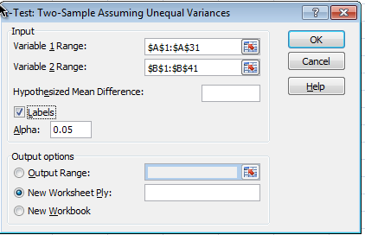
Output for the t-Test will be presented in new worksheet.

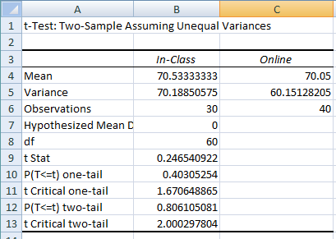

Above output shows that, mean exam scores among ‘In Class’ students was 70.5 and 70.05 among ‘Online’ students. The t-test statistic was 0.25 and p-value for two-tailed test was 0.81

The two-tailed p-value is greater than 0.05 cut off value. We fail reject null hypothesis and conclude that there was no statistically significant difference in mean exam scores between ‘In Class’ and ‘Online’ students.

